**CPRS QUICK START GUIDE FOR RESIDENTS**

CPRS Tab by Tab is a series of online training PowerPoint videos for CPRS. It is very extensive and not all of it applies to students. We’ve curated the highest yield information for you. If the slides aren’t listed in the packet you can skip past them (though you are welcome to watch them if you wish). You’ll be going through the sections out of order. This is designed to mimic how you are likely to go through a chart when admitting a new patient.

Since each region’s implementation of CRPS is slightly different the notes beneath the slide descriptions try to explain what those differences are. If you see ***Action Item*** this is a link to a quick guide on how to customize CPRS to make your life easier. Hold down the Ctrl key and click on it to go to the instructions for customization. Follow the instructions for the action item and then Ctrl-click on the ***Return to the Tab by Tab Training*** to return to where you were

We do not cover the following tabs: Problems, Orders, Consults and Surgery. While these tabs can contain useful information, you should instead focus on higher yield areas first.

[Click here to load CPRS Tab By Ta](https://www.vehu.va.gov/cprstraining/CPRSTabByTab/000000/index_000000.html)b

**PART 1: CPRS TAB BY TAB Review**

**Section 2: Signing on to CPRS/Patient Selection/Patient Record Flags**

* **Slide 1:** Signing into CPRS
  + Requires an **access code** and a **verify** **code**
    - An access code functions as a username and a verify code functions as a password
  + This is different from your Vista login (which starts with **vhapor***)*
    - The Vista login is what logs you into computers; it also will simultaneously log you into your VA email account, your VA Instant Message Account (Skype for Business) among other things
    - While it is possible to log into CPRS on a computer someone else has logged into using their Vista account you should generally **not** do this
* **Slides 3-5:** How to log-in to CPRS
* **Slides 9-13:** patient selection screen overview
* **Slides 23-24:** searching for specific patients
  + Can find them by typing in their name (last name, first name)
  + A second, and more commonly used method, is to search by Last initial and Last four of their social security number
    - Ex: John Doe 123-45-6789 would be searched for as D6789

* Action Item: set-up patients for your team to be displayed by default
* **Slide 25-26:** patient selection details
* **Slides 27-31:** patient record flags

**Section 12: Notes Tab Part 1 – Accessing Data**

* **Slides 1-5:** Notes tab layout
* **Slides 6-18:** View options for notes
* **Slides 19-30:** Custom views
  + Sorting notes by ‘Title’ is very helpful while on the inpatient service and is the recommended default
  + This allows you to skim the note titles and find ones relevant to your current admission
    - For example, if your patient is being admitted for chest pain the note title ‘Cardiology – Consult’ would be of interest to you and could easily be found (if one exists)
* **Slides 31-34:** Searching for specific titles
* **Slides 35-41:** Setting a custom view as the default view
  + For the inpatient service 500 notes strikes a good balance between load times and historical note reviewing for your default status
  + If you need to go back further you can always put in a larger number of notes to return (1000, 2000, whatever). CPRS may take a while to load them but it can be helpful
    - Just don’t save this as your default view or it’ll happen every time
* **Slides 42-46:** Search for text within notes
* **Slides 47-51:** Icon legends

**Section 25: Customizing Your CPRS – Notes, Options, Graphs**

* **Slides 7-24:** Creating a default list of Note Titles (*don’t forget to click save changes when done!*)
  + To get here click on ‘Tools’ in the file menu and then click on ‘Options’ (all the way at the bottom of the list)
    - Then, click on the ‘Notes’ (third from the left)
  + As a student, you have specific note titles you should be using
  + When you first use CPRS and create a new note you’ll see an alphabetized list of all the available note titles
  + You can type in the name of the note title each time but this is tedious and, instead, you can set your preferred titles to appear at the top of the list
  + Inpatient Medicine note titles (*please include a space before and after every hyphen*)
    - **INTERNS**
      * *Admission note*
        + Wards: INPAT – MED – HIST&PHYS
        + ICU: ICU – MED – INT - ADMIT
      * *Progress note*
        + Wards: INPAT – MED – INT – PROGRESS
        + ICU: ICU – MED – INT - PROGRESS
    - **RESIDENTS**
      * *Admission Note*
        + Wards: INPAT – MED – RES – ADMIT
        + ICU: ICU – MED – RES - ADMIT
      * *Progress note*
        + Wards: INPAT – MED – RES – PROGRESS
        + ICU: ICU – MED – RES - PROGRESS
    - **BOTH**
      * *Discharge Instructions*
        + DISCHARGE INSTRUCTIONS – MEDICINE MULTIDISCIPLINARY
      * *Cross Cover Note*
        + INPAT – CROSS COVERAGE NOTE
        + Optionally, can addend a progress note and add the primary team on as co-signers but this is a preferred method
      * *Code Status Documentation (must be done for all patients)*
        + CODE STATUS
        + Will automatically generate a code status order
      * *Continuing CPA/BiPAP for people already using it at home (must be ordered this way)*
        + INPAT – NIPPV ORDERS
        + Will automatically generate the order for RT
      * *Sleep Medicine E-Consult order (Outpatient sleep studies must be ordered this way)*
        + SLEEP MEDICINE – E-CONSULT ORDER
        + Will automatically generate the consult for Sleep Medicine
      * *HIV (HIV tests must be ordered this way)*
        + HIV <HIV ANTIBODY TEST CONSENT>
      * *Cardiac/Respiratory Arrest Documentation*
        + CODE99
      * *Procedure Notes*
        + Generally the note title is ‘PROCEDURE – [NAME OF PROCEDURE’
        + PROCEDURE – THORACENTESIS/PARACENTESIS/CENTRAL VENOUS CATHETER/ARTERIAL LINE/LUMBAR PUNCTURE
  + Outpatient Medicine note titles (please include a space before and after every hyphen)
    - Primary Care New Patient Intake: PC – NEW
    - Primary Care Follow-up Appointment: PC – FOLLOW UP
    - Primary Care Results Letter: PC – RESULTS LETTER
    - Primary Care Aftervisit Summary: PC – AFTERVISIT SUMMARY
    - Primary Care Medication List: PC – MEDICATION LIST
    - Primary Care Non-visit communication: PC – NON-VISIT
    - Primary Care Phone Appt: PC – PHONE APPOINTMENT
  + Please consult your staff for other note titles that are useful
  + You’ll learn how to use these in the next section
* **Slides 25-30:** Implement our new preferred note titles

**Section 13: Notes Tab Part 2 – Writing Notes**

* **Slides 1-7:** Creating a note
  + Medical students require co-signers for their notes (as the video indicates). This typically is the intern with the patient or the team’s resident. Please let your medical students know which of the team to be their co-signer
  + Notice the note titles we just set up now appear above the divider and are available for quick picks
* **Slides 8-18:** How templates work

* Action Item:set up default admit and progress note templates
* **Slides 25-27:** Saving drafts of notes
  + To get back into the note, right click and choose ‘Edit progress note’

**Section 17: Discharge Summary Tab**

* **Slides 1-9:** Discharge summary tab layout
  + Discharge summaries are a great place to gather information on your patient
  + When creating discharge summaries do NOT use the default template

* Action Item: Learn how to find the default discharge summary template

**Section 3: Cover Sheet Tab**

* **Slides 24-25:** Allergies
* **Slides 41-48:** Vitals
  + The vitals section is a good for a general overview but does not contain detailed information on I&Os, O2 use, lines/drains/etc. There is a separate tool called the ‘Clinical Flowsheet’ that stores this information
  + The ICU uses its own system. You will get access to this during your ICU rotation

* Action Item: Learn how to access the clinical flowsheet

**Section 18: Labs Tab**

* **Slides 1-4:** Layout of the Labs Tab
* **Slides 5-7:** Viewing cumulative labs
  + Located at the bottom of the list at PVAMC
* **Slide 8:** Reviewing all results in reverse chronological order (All Tests by Date option)
* **Slides 9-15:** Searching for selected tests by date
* **Slides 16-29:** Use the worksheet to review specific labs
  + The worksheets view is one of the best ways to review labs efficiently
* **Slides 30-31:** Microbiology reports
  + - Things that appear in this selection: Blood/urine/wound cultures
    - Things that do NOT appear in this selection: C. Diff (must search for this via worksheet or other search options)
* **Slides 32-36:** Labs Test Information
* **Slide 37:** Anatomic Pathology
  + Also found in the Reports Tab
* **Slide 38:** How to find the status of a lab (pending, drawn but not resulted, completed)
  + This can also be seen in the Orders tab

**Section 7: Meds Tab – Part 1**

* **Slides 1-5:** Meds tab general layout
* **Slides 6-9:** Outpatient Meds Tab view options
* **Slides 10-17:** Introduction to different columns
* **Slides 18-25:** Medication Statuses
* **Slides 26-33:** Outpatient medication details
* **Slides 34-36:** Returning to Meds Tab views with option 1 (Sort by Status/Exp Date)
* **Slides 37-42:** Returning to Meds Tab views with option 2 (Sort by Status Group/Status/Location/Drug Name)
  + This is good view for inpatient teams
* **Slide 43:** Returning to Meds Tab views with option 3 (Sort by Status)

**Section 19: Reports Tab**

* **Slides 1-4:** Layout of the Reports Tab
  + Medication administration times can also be found in the Meds Tab by double-clicking on an inpatient medication
* **Slides 5-6:** Clinical Reports
* **Slides 7-14:** Reviewing active and old medications (inpatient and outpatient)
* **Slides 15-21:** Reviewing Radiology reports
  + Can also be found by clicking on ‘Imaging’ located further down the list though that’ll only show local reports

**Section 20: CPRS Reports Tab Remote Data View**

* **Slides 1-8:** Introduction to Remote Data
* **Slides 9-11:** Using Remote Date to view radiology reports from other VA facilities
* **Slides 12-15:** Using Remote Data to view medications from other VA facilities
* **Slides 16-:** Viewing health summaries from other VA facilities

* Action Item**:** Learn how to review data from other VA facilities locally in CPRS
  + Note: not every VA site may display information. If it does not, please use VistaWeb to see this material

**Section 21: CPRS Reports Tab using VistaWeb**

* **Slides 1-5:** Introduction to VistaWeb
* **Slides 6-13:** Using VistaWeb to view radiology reports from other VA facilities
* **Slides 14-19:** Using VistaWeb to view medications from other VA facilities
* **Slide 20:** Using VistaWeb to see consults and procedure results from other VA facilities
* **Slides 21-27:** Using VistaWeb to review progress notes from other VA facilities

**Section 9: Orders Tab Part 1 - Views**

* **Slides 1-6:** The Default view in the Orders Tab (the Active Orders view)
* **Slides 7-10:** Other available pre-defined view options
* **Slides 11-21:** Customizing the Orders view to search for orders
* **Slides 22-28:** the layout of the Active Orders view (the default view)

**Section 10: Orders Tab Part 2 – Writing Orders**

* **Slides 1-11:** Writing Delayed Orders
* **Slides 12-25:** Putting in orders
  + At the Portland VA this window is divided into Inpatient Orders and Outpatient Orders
  + The actual layout is different at PVAMC than in the Tab by Tab but the same principles apply

* + Action Item: Review how to write delayed orders
* **Slides 26-34:** Using order sets
* **Slides 35-39:** Signing orders
* **Slides 40-45:** Manually releasing orders and Auto DC orders
  + If the specific trigger for the delayed order (such as admission to General Medicine) wasn’t met because, for example, the patient was admitted to General Surgery instead, you can still release some (or all) of the delayed orders

**Section 11: Orders Tab Part 3 – Quick Orders and Other Order Actions**

* **Slides 1-22:** Creating personal quick orders
* **Slides 23-39:** Service connected orders
* **Slides 40-45:** Setting up alert notifications for orders
* **Slides 46-51:** Setting up order flags

**Section 15: Consult Tab**

* **Slides 1-9:** Layout of the consults tab
* **Slides 10-12:** Where to find the Icon legend for the consult tab
* **Slides 13-18:** Displaying the results of an Interfacility consult
* **Slides 19-31:** Taking actions on consults
  + You CANNOT use the ‘add comments’ feature to alert the primary care providers

* + Action Item: Learn how to communicate significant findings to primary care providers
* **Slides 32-41:** How to complete consults

**Section 24: Customizing Your CPRS – Lists/Teams**

* **Slides 1-6:** How to create a default patient list and creating source combinations
* **Slides 7-18:** Making the combination list your default list in CPRS
* **Slides 19-32:** Creating a Personal List
  + This allows you to receive notifications on a patient even if you aren’t the ordering provider
* **Slides 33-36:** Assigning yourself to Teams

**Section 26: IMedConsent**

* **Slides 1-20:** Graphical representation of IMedConsent
  + Make sure you have a USB signing device in the computer
* **Slides 21-23:** How to find patient educational information in ImedConsent
* **Slides 24-27:** Holding an iMedConsent for signature

**Section 27: VistA Imaging Display**

* **Slides 1-9:** Layout of VistA Imaging Display
* **Slides 10-14:** Viewing images
* **Slides 15-16:** Viewing EKGs
* **Slides 17-19:** Viewing consents
* **Slides 20-22:** Customizing view options

**PART 2: ACTION ITEMS & SCREENCAP GUIDES**

**How to set a default team**

*You can have CPRS show your current team’s patients by default whenever you log in.*

1. **Go the patient selection screen**
   1. *Red Arrow*: In the menu bar choose ‘File’ then ‘Select New Patient’

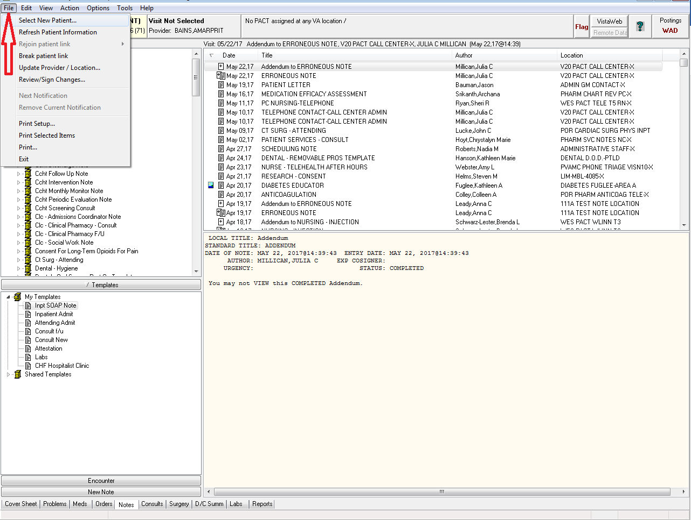

1. **On the patient selection screen find your team**
   1. *Red Arrow*: for people on the General Medicine service click on the Team/Personal button. For the MICU click on the ‘Specialties’ button.
   2. *Blue Arrow*: type the name of the team here
      1. General Medicine Team Names:
         1. Naming format: Teamgm[team number] (all one word without spaces)
         2. For example, GM1 would be ‘Teamgm1”
      2. MICU Team Names
         1. Name: ‘Medical Icu’
      3. For other teams (such as consult services) please ask your fellow or attending the proper team name

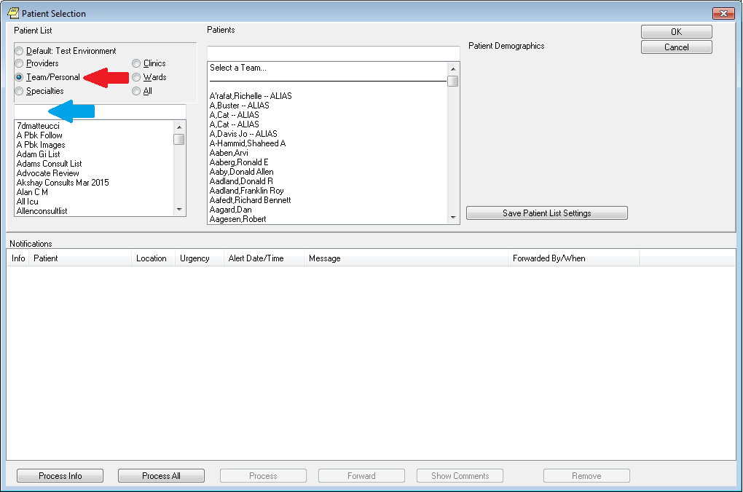

1. **Once you’ve typed your team name into the field and found it the team’s patients should be listed in the center**
   1. I chose the team ‘Test Environment’ and if you look in the center column all the patients start with Zztest. These are the patient in the test environment team
   2. *Red Arrow*: click on ‘Save Patient Listings’ when you’ve found your team
      1. From now on, whenever you open CPRS the team you picked will show up by default

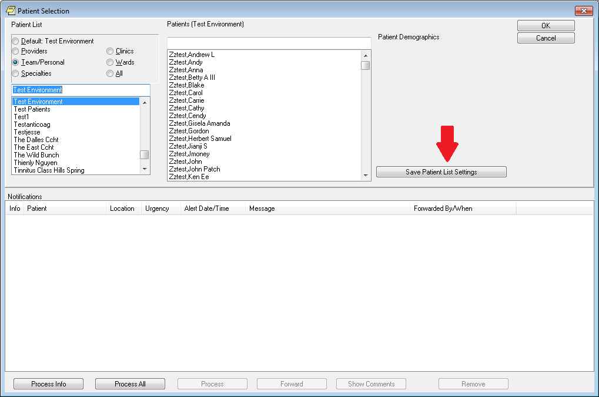

Return to the Tab by Tab Training

**How to set up note templates in CPRS**

1. **Click on new note to start a note**

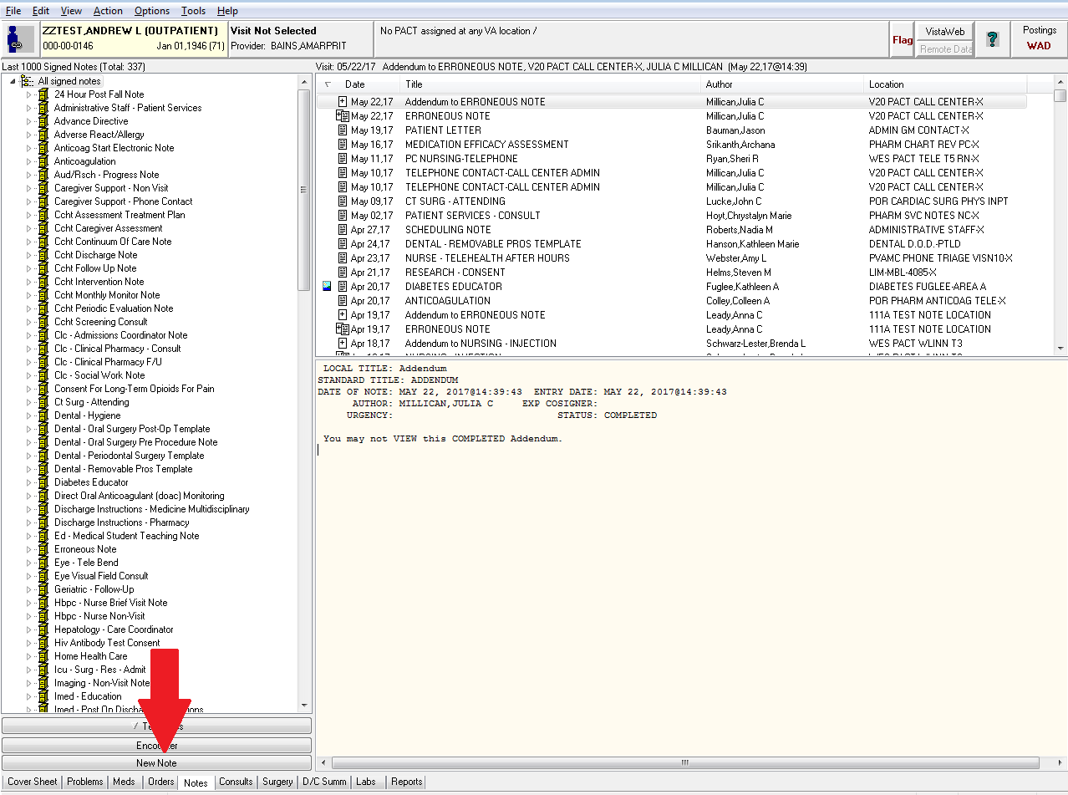

1. **When working in a test patient’s chart you will see this alert**
   1. This alert appears because CPRS wants to know what visit this note should be associated with
   2. *Blue arrow:* notice it says ‘Visit Not Selected.” This means the patient is not located at any VA clinic or hospital
      1. If the patient is in the hospital instead of ‘Visit Not Selected’ you’ll see the patient’s ward and room number
      2. This alert won’t appear because CPRS knows the patient is admitted and will assume you want to associate your note with the hospitalization
   3. *Red Arrow:* CPRS brings up this little window to let you choose what visit you want to associate the note with
      1. The first section is ‘Clinic Appointments’ and lists the most recent clinic visits the patient had
      2. The second section is ‘Hospital Admissions’ and lists the most recent hospitalizations
      3. The third section lets you make an entirely new visit. You generally won’t ever use this one
   4. This is used to figure out how to bill this patient encounter
      1. If the patient is already in the hospital it won’t give you this alert because it will assume everything you’re doing is inpatient related (which it usually is)
      2. Since our patient is an outpatient CPRS wants to know what this note is in reference to
      3. For our purposes in training it doesn’t matter. Go ahead and double click on any of them.

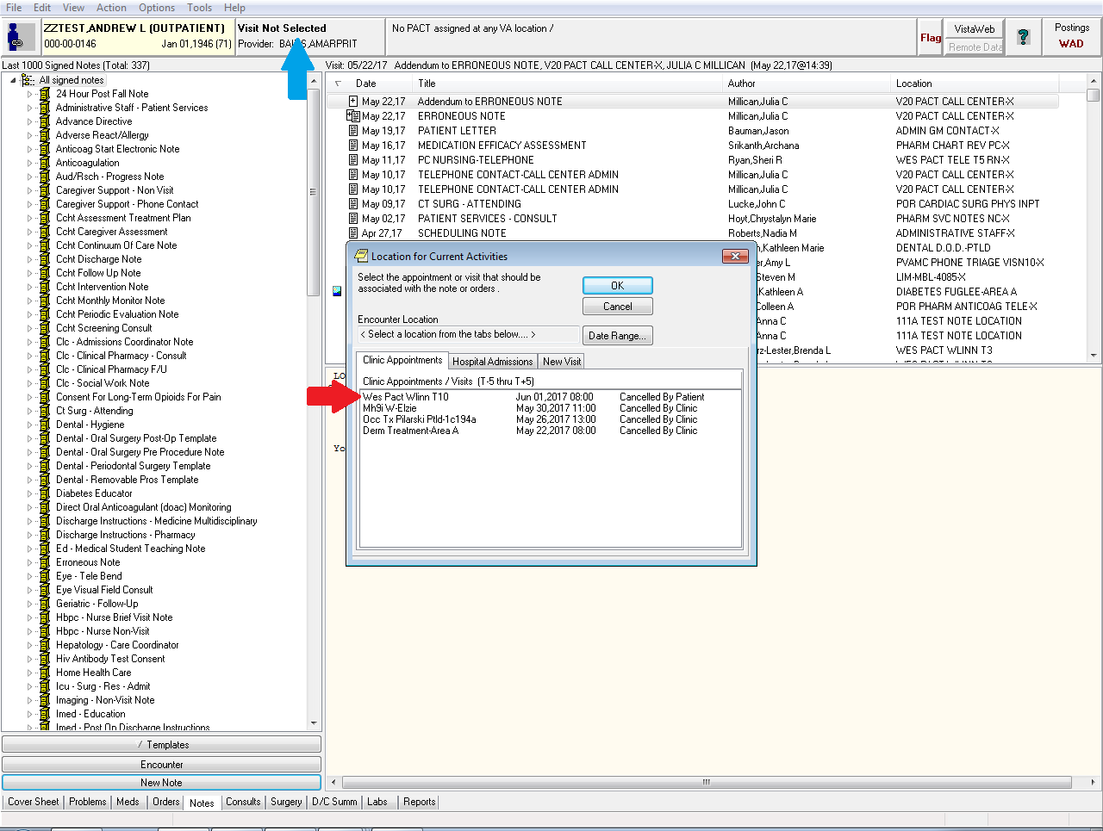

1. **Choose the appropriate document title**
   1. The document titles you saved in the previous section will appear here

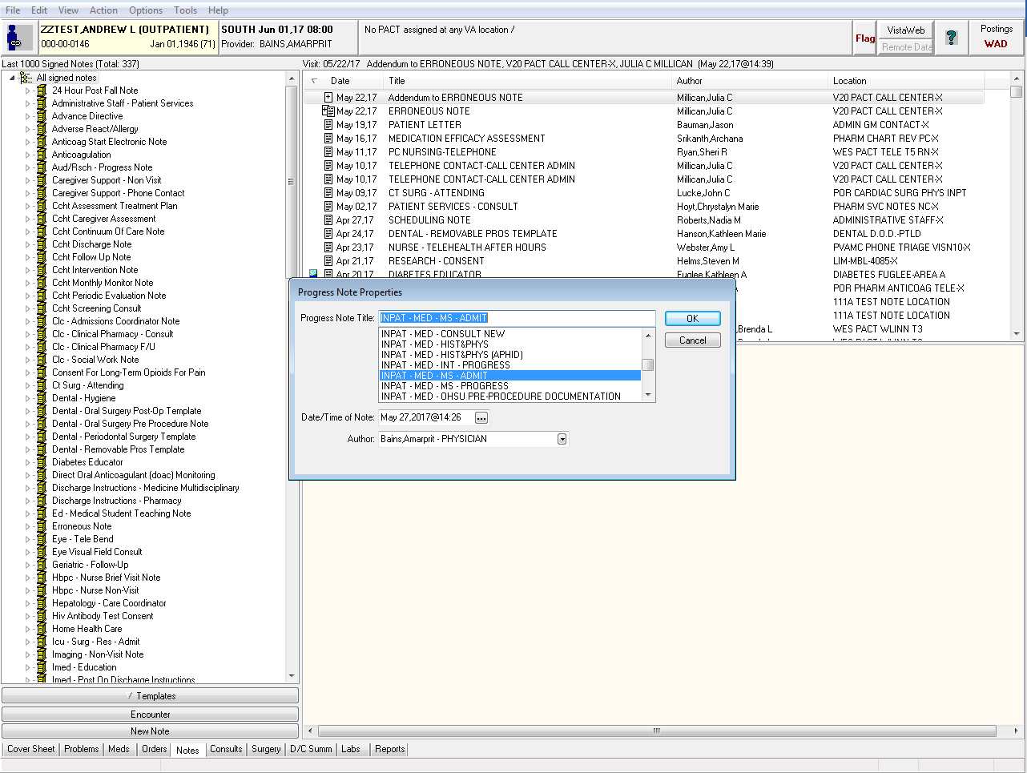

1. **Now you have a note titled INPAT – MED – HIST&PHYS OR INPAT – MED – RES - ADMIT with no content**

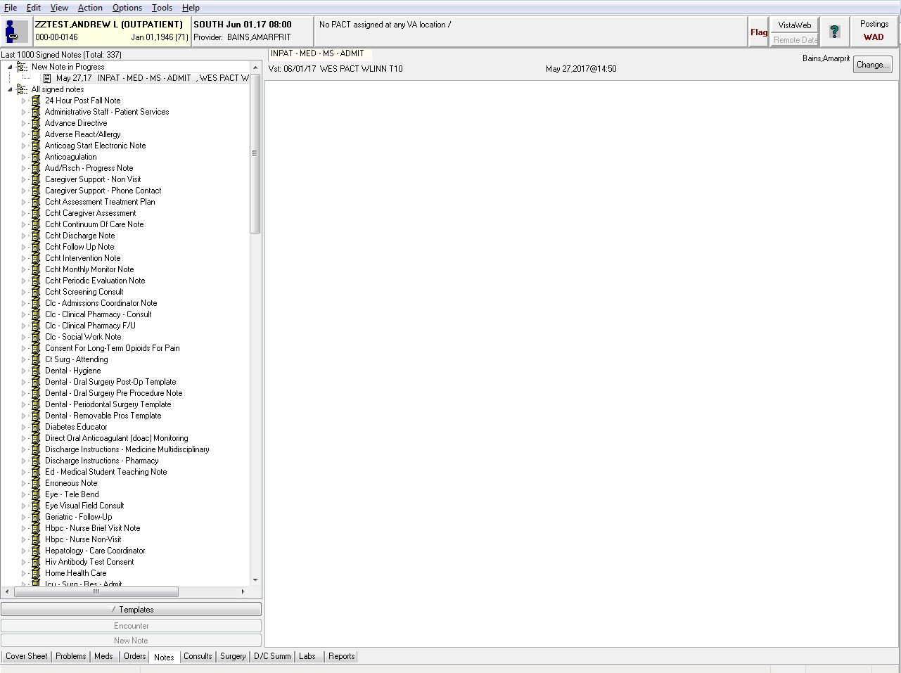

1. **You can free type if you want though doing this every time isn’t especially efficient**
   1. *Red Arrow:* click on the Templates button to bring up available templates

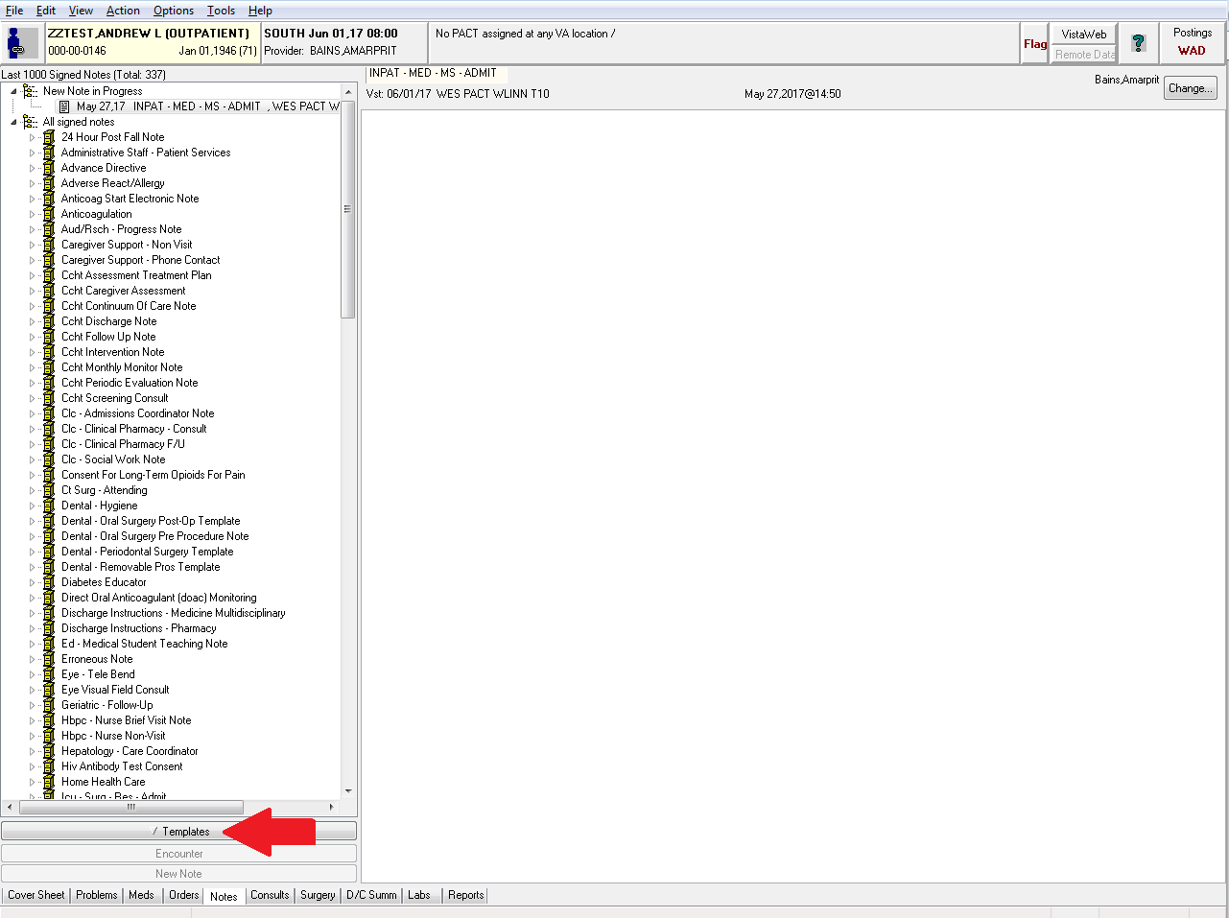

1. **Except you don’t have any and the area under templates is blank**

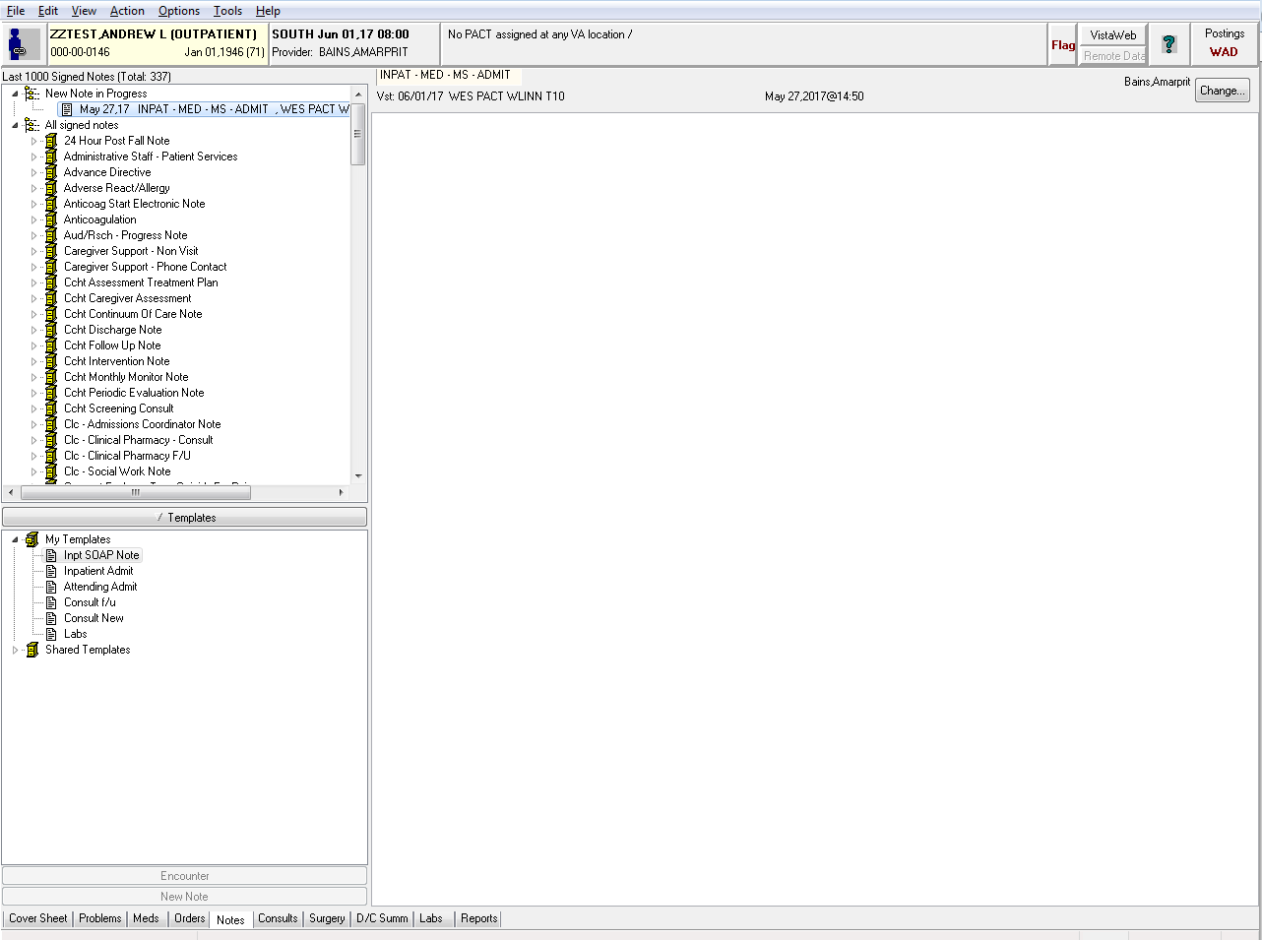

1. **The video covers shared templates but we’re going to have you set up your own right now**
   1. *Red Arrow:* in the file menu choose ‘Options’ and then ‘Edit Templates’

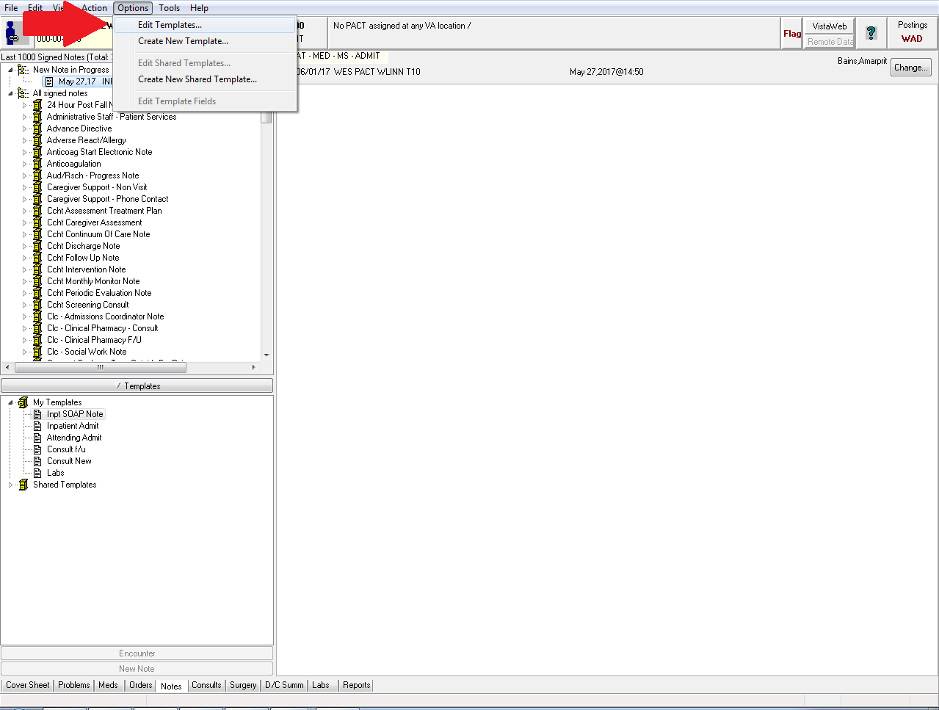

1. **This brings up the template editor**
   1. *Red Arrow:* click on ‘New Template’ to make a new template

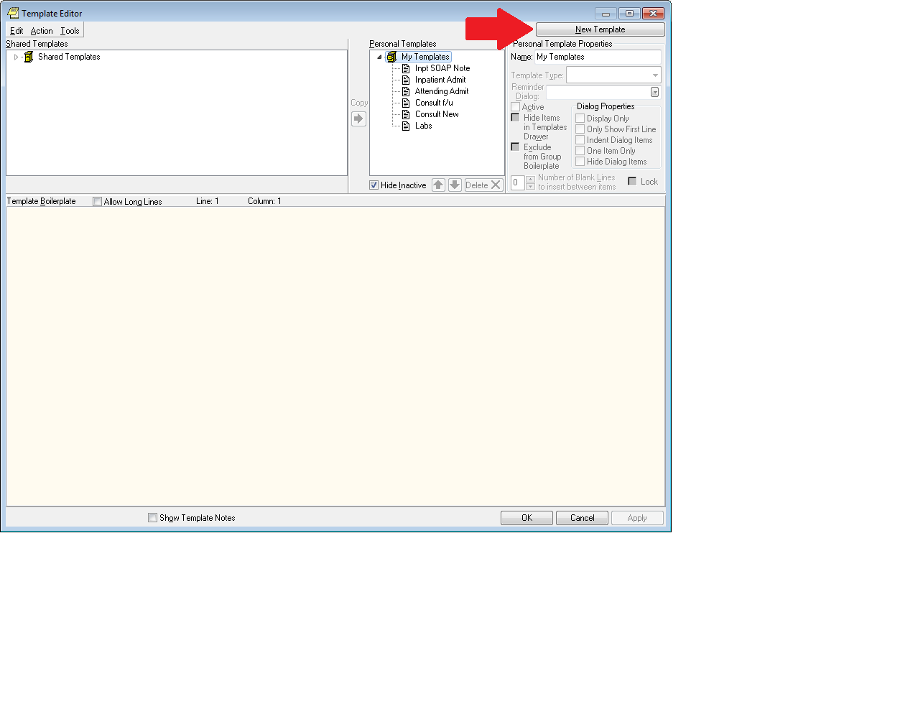

1. **You now have a new blank template named ‘New Template’**
   1. *Red Arrow:* shows you where the template will appear in your My Templates list
   2. *Blue Arrow:* you can rename your template here
      1. Name it ‘H&P (or whatever you want)’ –
         1. *The example below is for a med student admit note but the same principle applies*

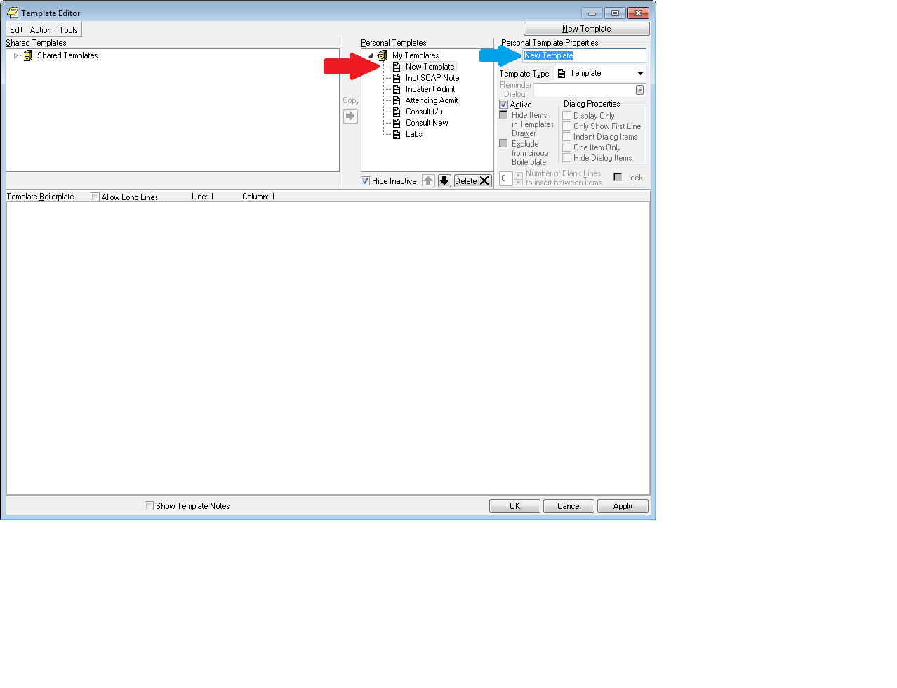

1. **Notice the name has also changed to ‘MS Admit’ in the My Templates list**
   1. The bottom part of the window is where you can write the text of your template
   2. However, we’ll provide you with a template you can use (and modify) to make things easier
      1. Scroll down to find the admit note template
      2. Highlight the admit note template
      3. Right click and select copy
      4. Go back to CPRS and right click in the template text field. Select paste
      5. *Green arrow*: be sure to click ‘Apply’ to save your changes
      6. Hit OK to close the template window

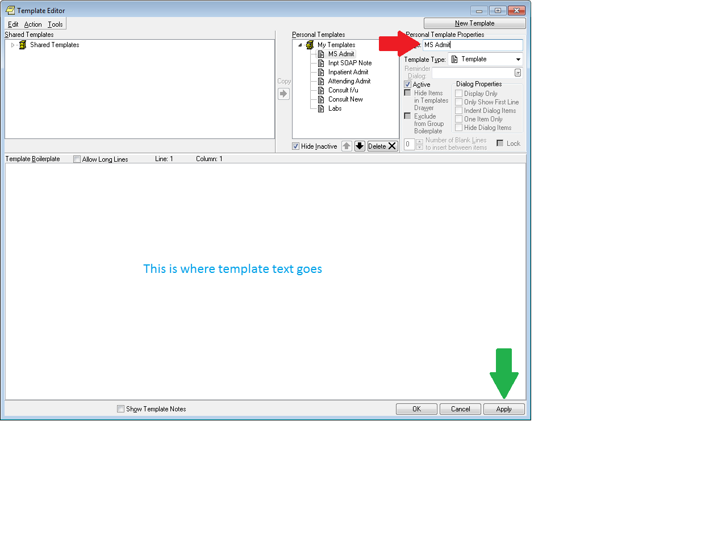

**ADMIT NOTE TEMPLATE**

ID: |PATIENT NAME FIRST,LAST| is a |PATIENT AGE| year old |PATIENT SEX|

PRIMARY CARE PROVIDER: |APT PATIENT PCP|

ASSOCIATE PROVIDERS:

_______________________________________________________

CC: |PATIENT NAME| presented with a chief complaint of

HISTORY OF PRESENTING ILLNESS:

PERTINENT ECU COURSE:

PAST MEDICAL HISTORY:

1.

2.

3.

REVIEW OF SYSTEMS:

SOCIAL HISTORY/HABITS:

NEXT OF KIN/FAMILY CONTACTS:

FAMILY HISTORY:

_______________________________________________________

MEDICATIONS:

THIS MEDICATION LIST WAS CONFIRMED WITH THE PATIENT OR FAMILY MEMBER:

YES (x) NO ( )

|ACTIVE/PENDING/EXPIRED MEDICATIONS (W/O SUPPLIES)|

=====================================================================

Pending prescriptions written within last 7 days

=====================================================================

|PDX PEND 1W MEDS|

=====================================================================

Remote VA Pharmacy medication/allergy information

=====================================================================

|REMOTE ACTIVE MEDICATIONS|

_______________________________________________________

PHYSICAL:

VITALS SIGNS

Blood pressure: |BLOOD PRESSURE|

Pulse: |PULSE|

Temperature: |TEMPERATURE|

Respirations: |RESPIRATION|

Weight: |PATIENT WEIGHT|

Height: |PATIENT HEIGHT|

Pain: |PAIN|

EXAM:

General:

HEENT:

Neck:

Chest:

Cardiac:

Abdomen:

Back/Extrem:

GU/Rectal:

Neuro:

Skin:

_______________________________________________________

LABORATORY DATA:

|LAB-WBC|

|LAB-HCT|

|LAB-MCV|

|LAB-PLATELETS|

|LAB-NA|

|LAB-K|

|LAB-CL|

CO2 |DIAGRAM C02|

|LAB-BUN|

|LAB-CREATININE|

|LAB-72HR CARDIAC ENZYMES|

_______________________________________________________

IMAGING:

OTHER DATA:

_______________________________________________________

IMPRESSION:

_______________________________________________________

ASSESMENT AND PLAN:

PROBLEM 1:

PLAN:

PROBLEM 2:

PLAN:

PROBLEM 3:

PLAN:

PROPHYLAXIS ISSUES:

_______________________________________________________

CODE STATUS:

The patient will be staffed with Dr. within 24 hours.

1. **You’ll notice our newly made template is now listed under ‘My Templates’**
   1. You can either click and drag ‘MS Admit’ into the notes field or double-click on it to populate the note with your template

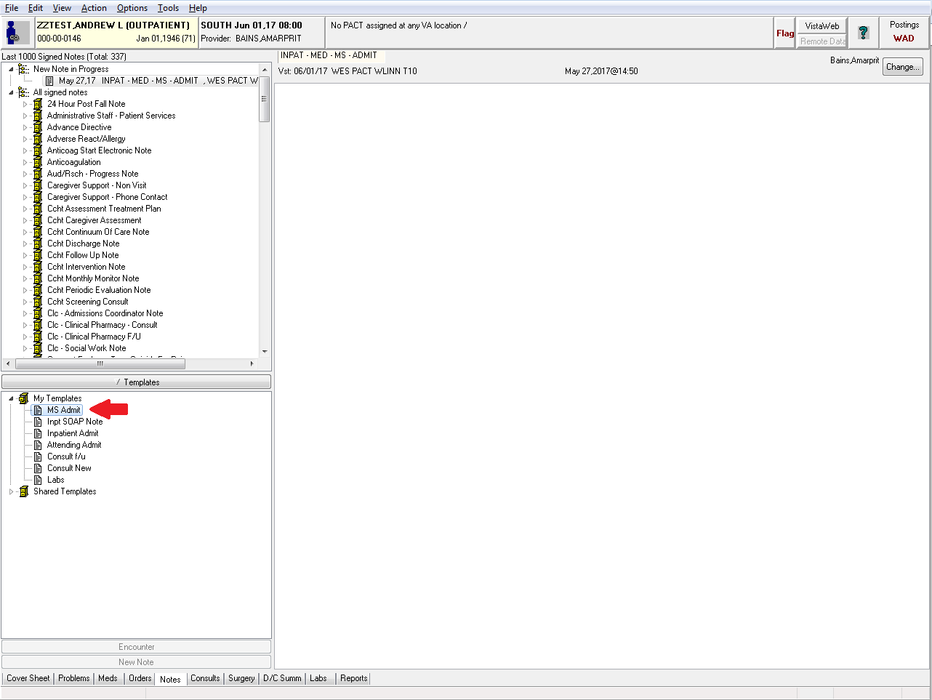

1. **Now your templated note is ready to go**

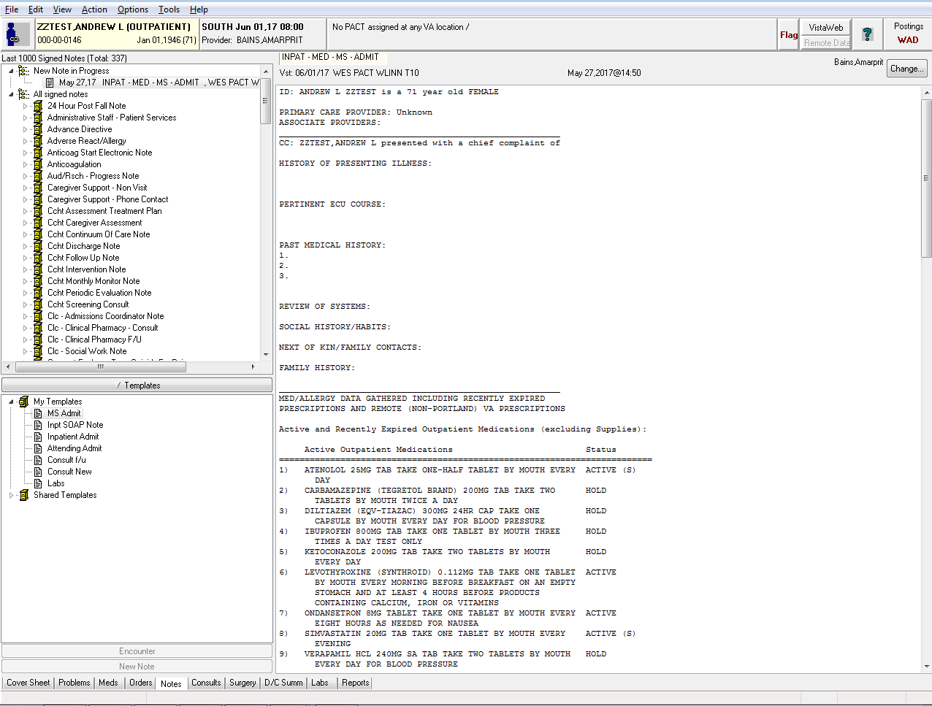

1. As an exercise, create another template called ‘MS Progress’ using the pre-made template below
   1. The text written like |This| is computer code. When drag the template into your note CPRS will pull in the relevant patient data
      1. For example, | Patient Age | will pull in the that specific patient’s age
   2. You can re-adjust and reformat the note however you like but be sure not to delete or modify the computer code otherwise the data won’t load properly

**PROGRESS NOTE TEMPLATE**

S: Patient is |PATIENT AGE|

O: |V-LOHI 24 VITAL SUITE| ; I/O

HEEH:

CV:

Lungs:

Abdo:

Ext:

Skin:

MS:

Meds: |ACTIVE MEDICATIONS - CLEAN|

Allergies: |ALLERGIES/ADR|

Labs:

|CHEM7-NA|: |CHEM7-CL|: |CHEM7-BUN|/ \ |CBC-HGB| /

------ : ------ : ------ |CHEM7-GLU| |CBC-WBC|-------- |CBC-PLATELETS|

|CHEM7-K|: |CHEM7-CO2|: |CHEM7-CRE|\ / |CBC-HCT| \

Impression:

Plan:

I have seen and discussed the patient with my supervising practitioner,

Dr. , and Dr. agrees with my assessment and plan.

1. **You can change the formatting of your templates within the template editor**

Return to the Tab by Tab Training

**How to create a discharge summary and use the proper template in CPRS**

The default discharge summary template is NOT the one that you should be using. It will eventually be replaced with the template below. For now, follow the instructions below to find the proper template.

1. **Go to the discharge summary tab and select ‘New Summary’**
   1. *Red Arrow*: Location of the Discharge Summary tab
   2. *Blue Arrow:* How to create a new discharge summary

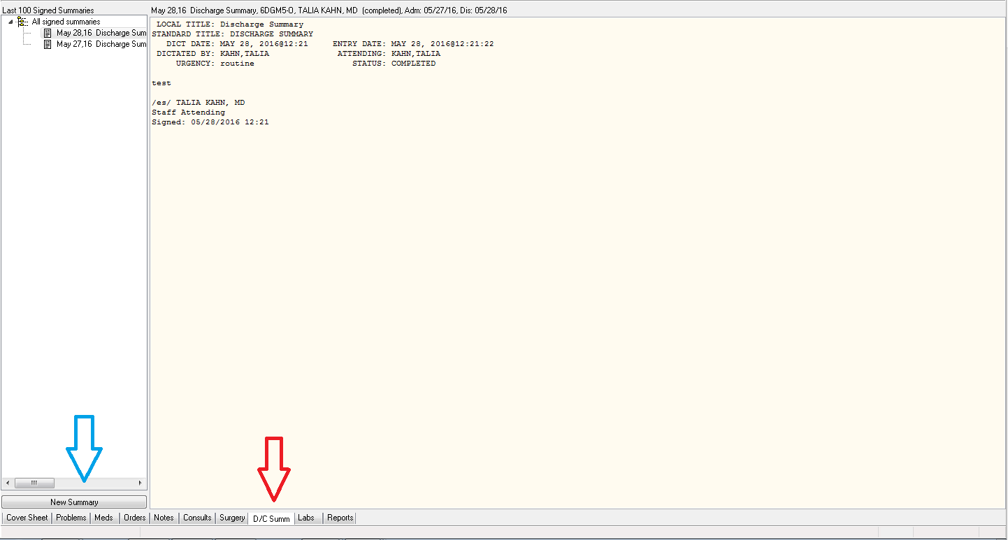

1. **Creating the discharge summary**
   1. Any note title will work. You can just choose the top one ‘DCS <DISCHARGE SUMMARY>’
   2. *Red Arrow:* Fill in the name of your attending here
   3. *Blue Arrow:* choose the associated admission for the summary
      1. Note: if the patient was converted from Obs to inpatient there will be two admission dates
         1. The first is for when the patient was discharged from Obs and admitted
            1. This discharge summary can be very brief and can instruct people to refer to inpatient discharge summary
         2. The second is for when the patient was discharged from the inpatient service

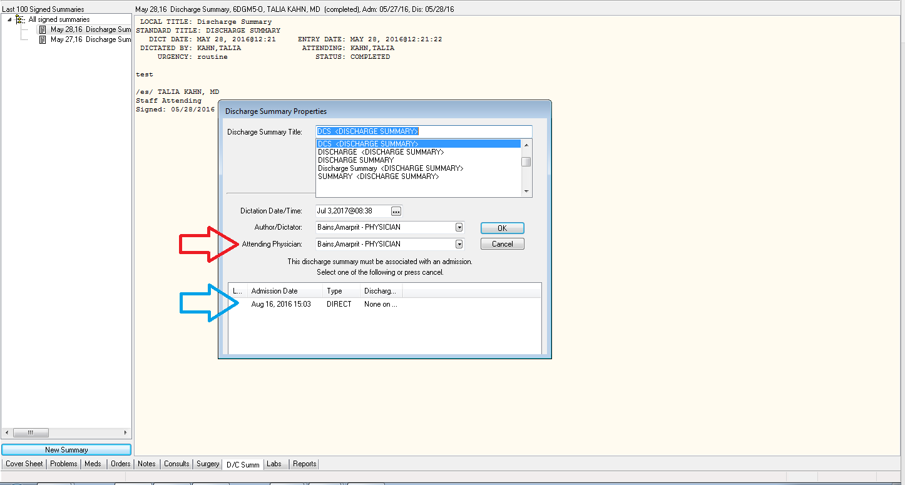

1. **The default template will appear**
   1. *Red Arrow:* hit OK and then delete all the text that appears

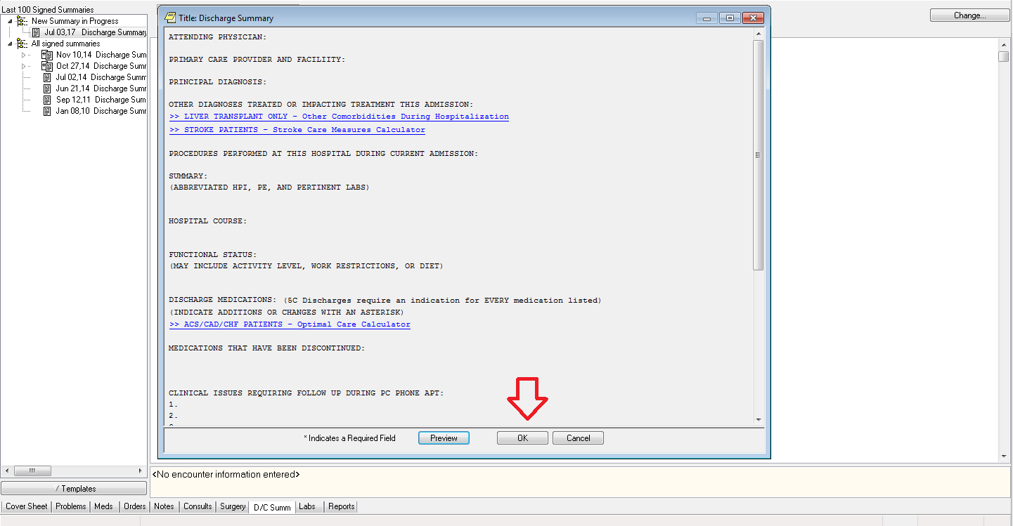

1. **Now that you have an empty note you can add the proper template**
   1. *Red Arrow:* Click on the Templates button

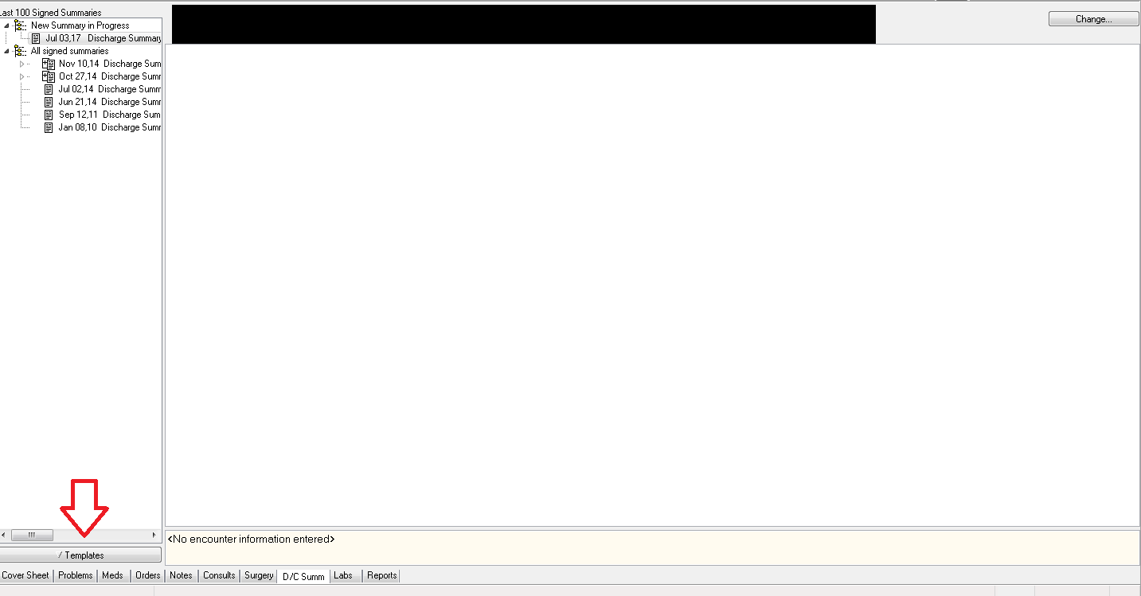

1. **The proper discharge summary template is in the shared templates section**
   1. *Red Arrow:* choose ‘Shared Templates.’ Click on the little triangle to expand the list

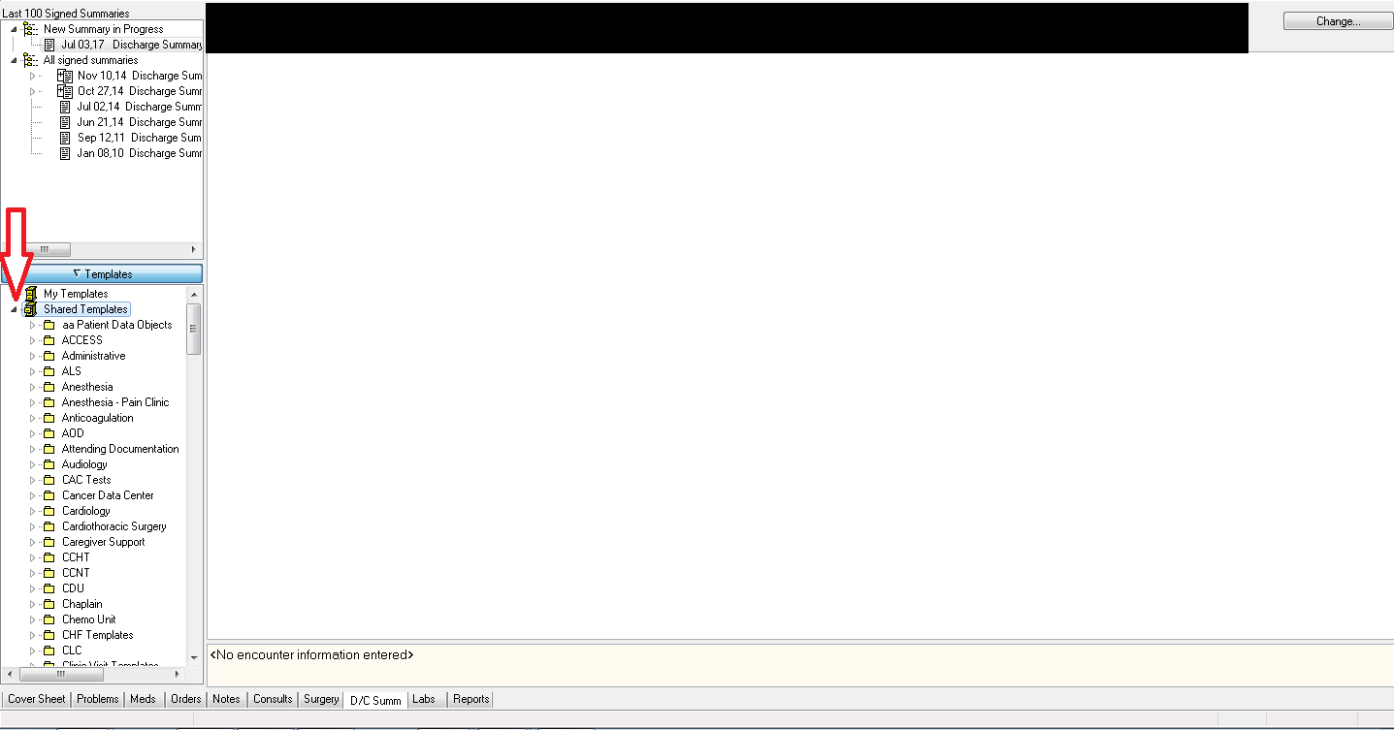

1. **Finding the folder with the template**
   1. *Red Arrow:* Go to ‘NWIC’->’Discharge Process (Segura/Hunsaker)’->’Discharge Summary (2015’
   2. Either double click or drag and drop it into the discharge summary area

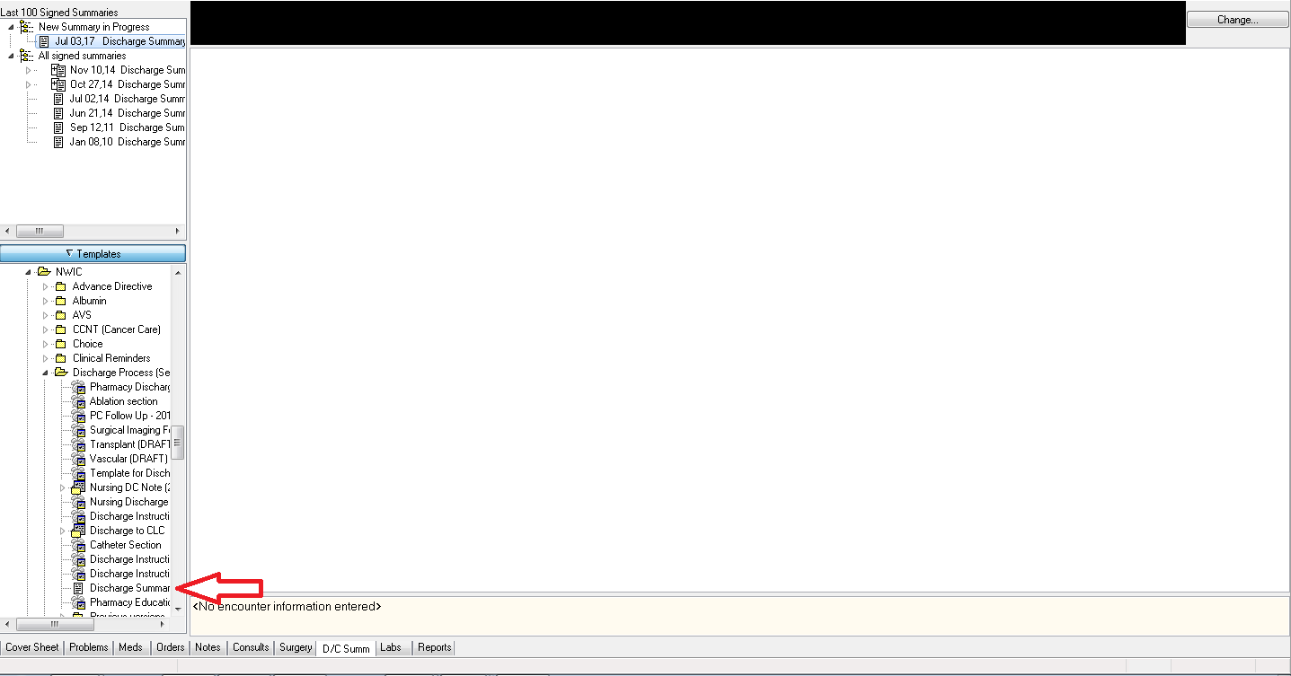

Return to the Tab by Tab Training

**Finding the Clinical Flowsheet**

The clinical flowsheet is where comprehensive patient vitals, I&Os, CIWA scores and other clinically relevant information is stored.

1. **The clinical flowsheet is a CPRS add-on program. It, like other CPRS add-on programs, is stored under the ‘Tools’ option in the menu bar**
   1. Red Arrow: click on ‘Tools’
   2. Blue Arrow: choose ‘Clinical Flowsheet’

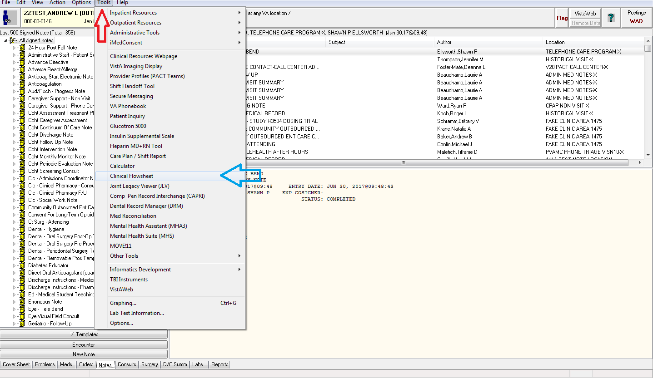

1. **Once it loads you can leave it open. Whenever you switch to a new patient in CPRS it will change as well**
   1. Red Arrow: change your date and time range here
      1. One oddity of this is that Saturday is cut off from the date selection screen. You can’t expand the window to see it. However, if you hover to the right of Friday on the edge of the screen it’ll let you choose Saturday. It’s annoying and weird.
   2. Blue Arrow: how to choose vitals

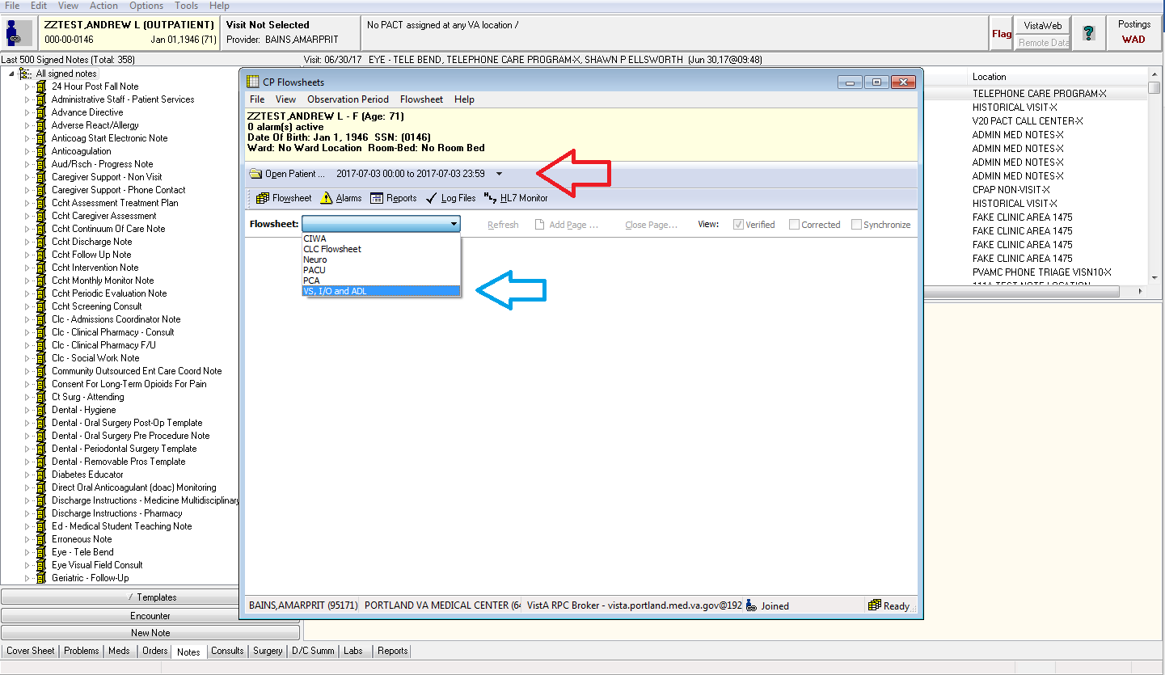

Return to the Tab by Tab Training

**How to view information from other VA facilities within CPRS**

*This applies to not just images but medications, vitals and labs. It essentially is taking the information you normally find in VistAWeb and putting it into CPRS*

1. **Go to the Reports tab**
   1. Below is the default view in the reports tab. Notice that ‘Imaging (local)’ is highlighted
   2. As the name would suggest, only reports from our local VA are being displayed

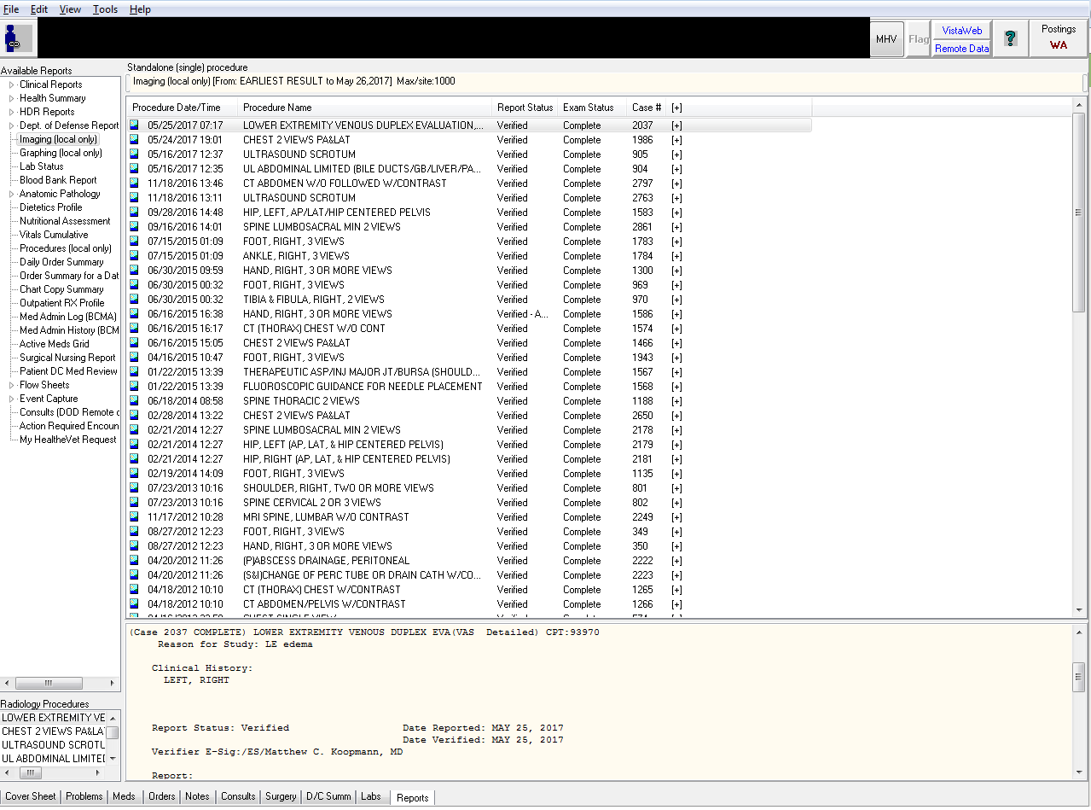

1. **The Remote Data Button**
   1. If the Remote Data button is blue it means there is data from other VA facilities available
   2. Click on the remote data button to see what sites are available

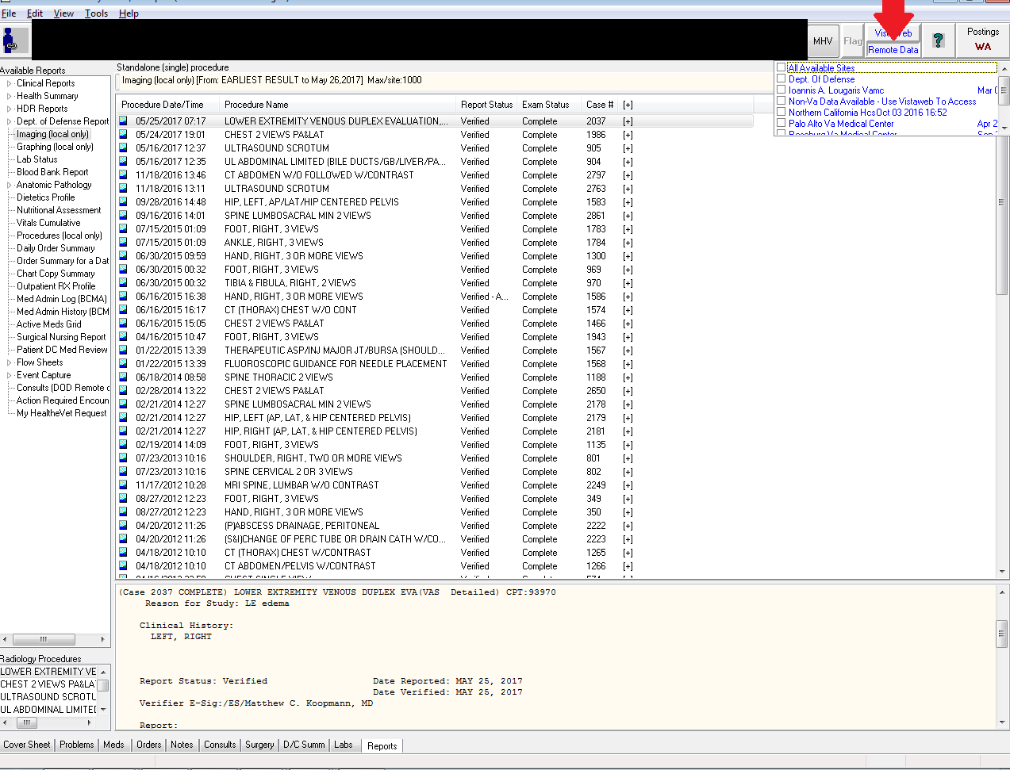

1. **Select which sites you want to import data from**
   1. The more sites you select the longer it will take to load though, generally, all sites will be fine
   2. *Red Arrow*:
      1. Select ‘All Available Sites’
   3. CPRS will refresh
   4. Click the Remote Data button again to make the little window with the sites go away

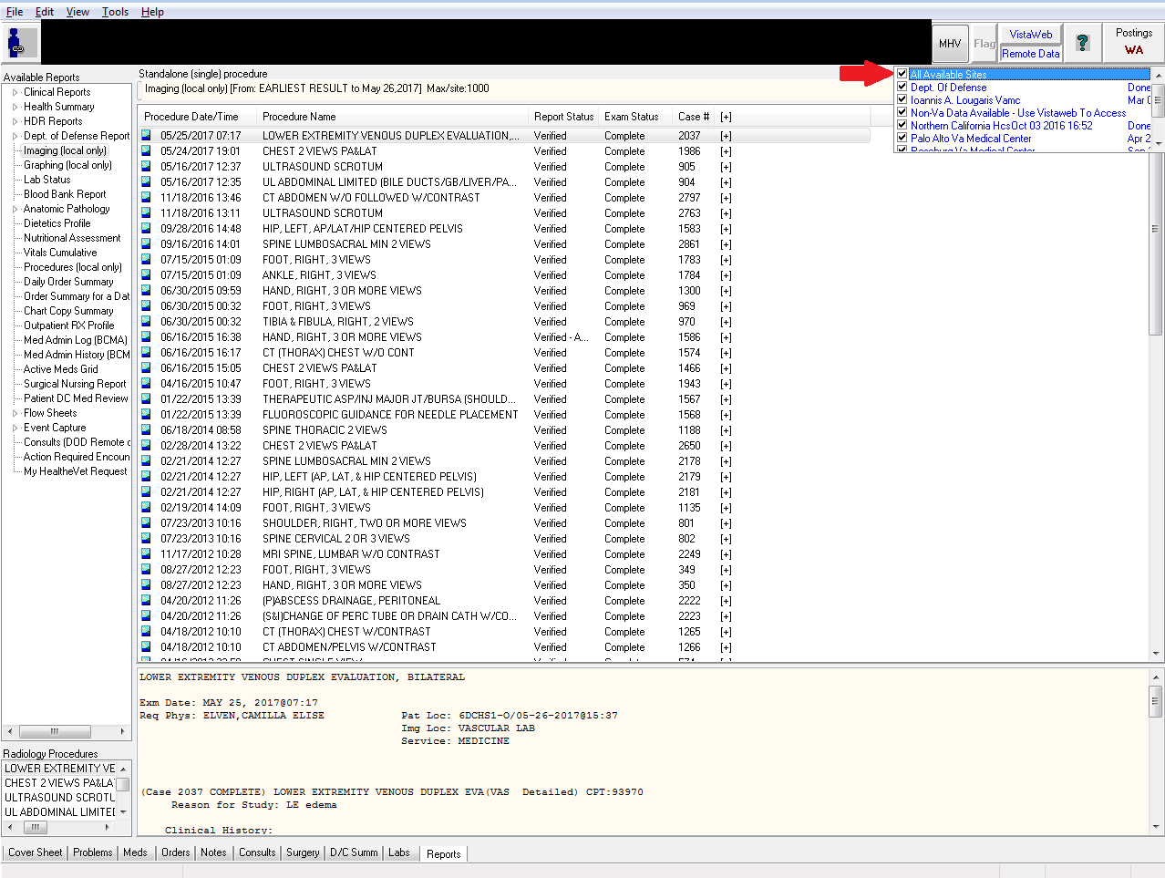

1. **Click on the little triangle next to ‘Clinical Reports’ to expand options**

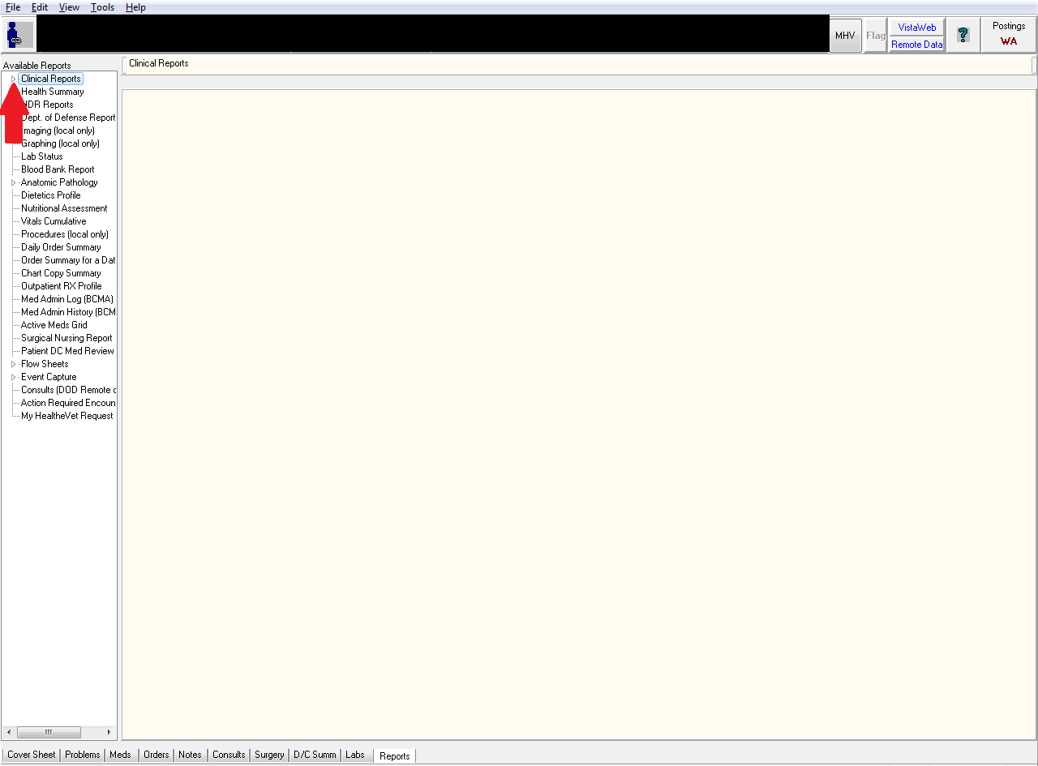

1. **Click on the little triangle next to Radiology to expand available options**

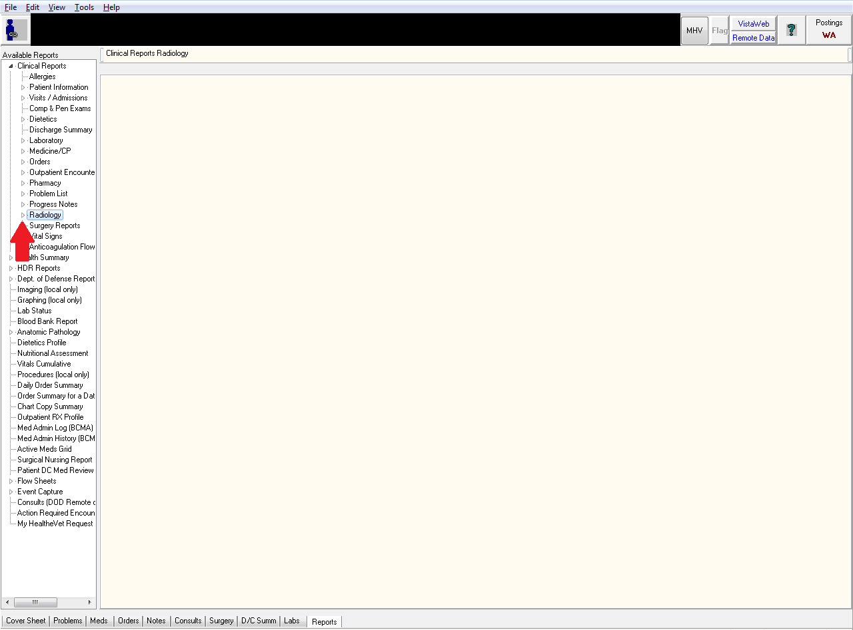

1. **Select ‘Report’**
   1. Notice how other VA sites are listed (Northern California VA in this case)
   2. Click on the individual study will bring up the radiology read below

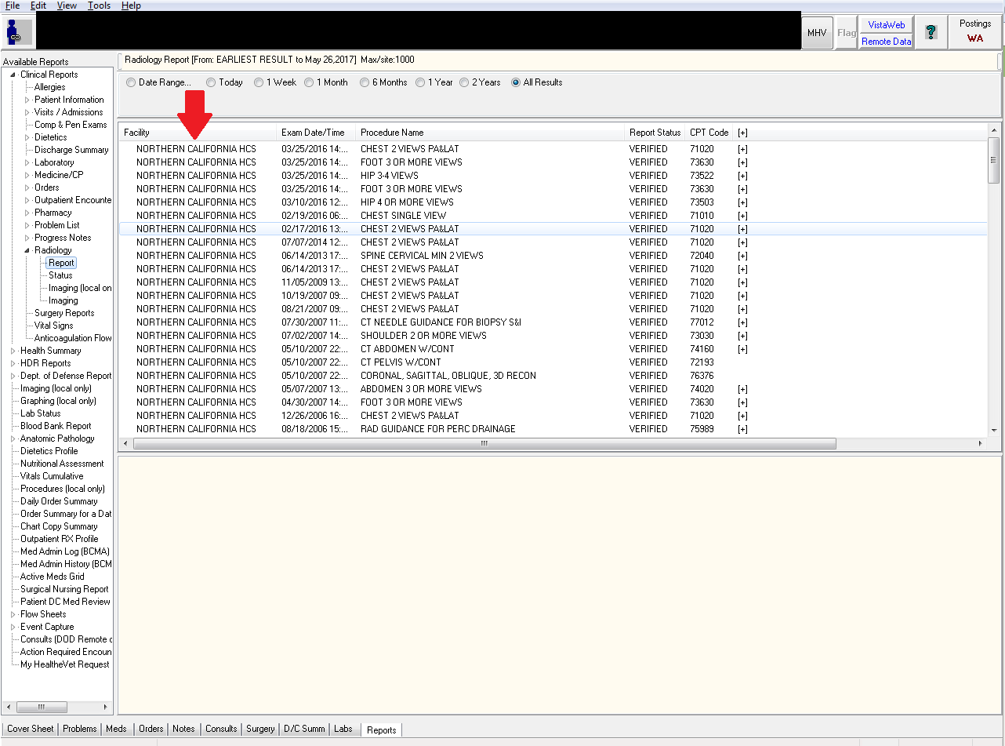

1. **To view Procedures, expand the ‘Medicine/CP’ section and choose ‘Brief Report’**
   1. *Red Arrow*:
      1. In this example the Medicine/CP section has been expanded
   2. *Blue Arrow*:
      1. You can select which VA facility you want and it’ll show relevant EKGs, Echocardiograms and other procedures
      2. Notice this patient has a 2005 TTE from the Sacramento VA with the report displayed just below it
   3. *Green Arrow:*
      1. Allows you to narrow the date range

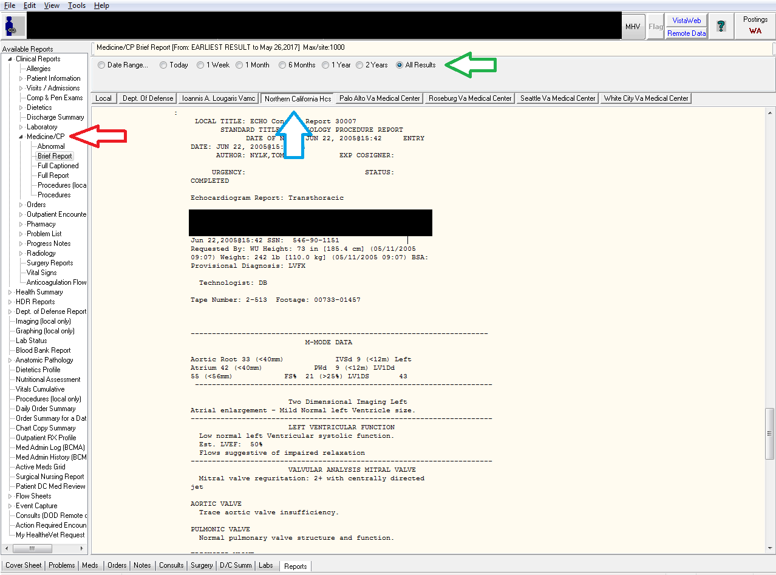

1. **Viewing remote medications**
   1. *Red Arrow:*
      1. Still within the ‘Clinical Reports’ section, expand ‘Pharmacy’ and choose ‘All Medications’
   2. *Blue Arrow:*
      1. Notice the meds have all been imported from the remote data sites
   3. *Green Arrow:*
      1. The easiest way to go through these medications is probably to sort via Start Time but you can choose which method of sorting works best for you
   4. As with local medications, clicking on the med will bring up details about it in the window below

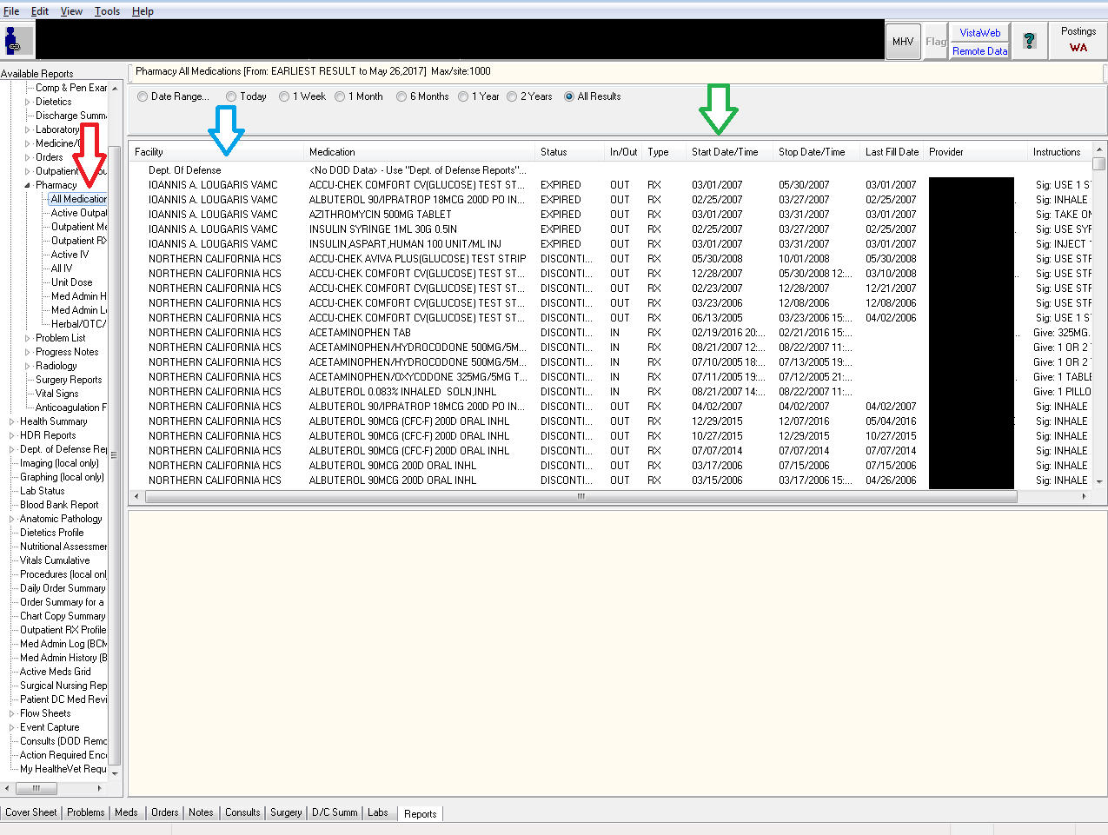

1. **This same method can be done for everything else in the ‘Clinical Reports’ section including labs, vitals and even progress notes**
   1. Choosing progress notes may lead to long load times so be careful when using it (though typically it should be fine)

Return to the Tab by Tab Training

**How to Write Delayed Orders (Pre-admit and Transfer orders)**

*Delayed admit orders are orders that are written before a patient is admitted to the hospital and go live the moment the patient arrives on the floor. It is a very useful way to get ahead on your work.*

Criteria:

* The patient is currently an outpatient
* You know which ward the patient will be admitted to

*Delayed transfer orders are for patients already in the hospital and moving from one subspecialty to another.*

**Creating a Delayed Admission Order**

1. **Go to the Orders tab**
   1. *Red Arrow:*
      1. It shows the patient’s status as “Visit Not Selected.” This means he is currently an outpatient and is appropriate for delayed admit orders
2. **Click on ‘Write Delayed Orders’**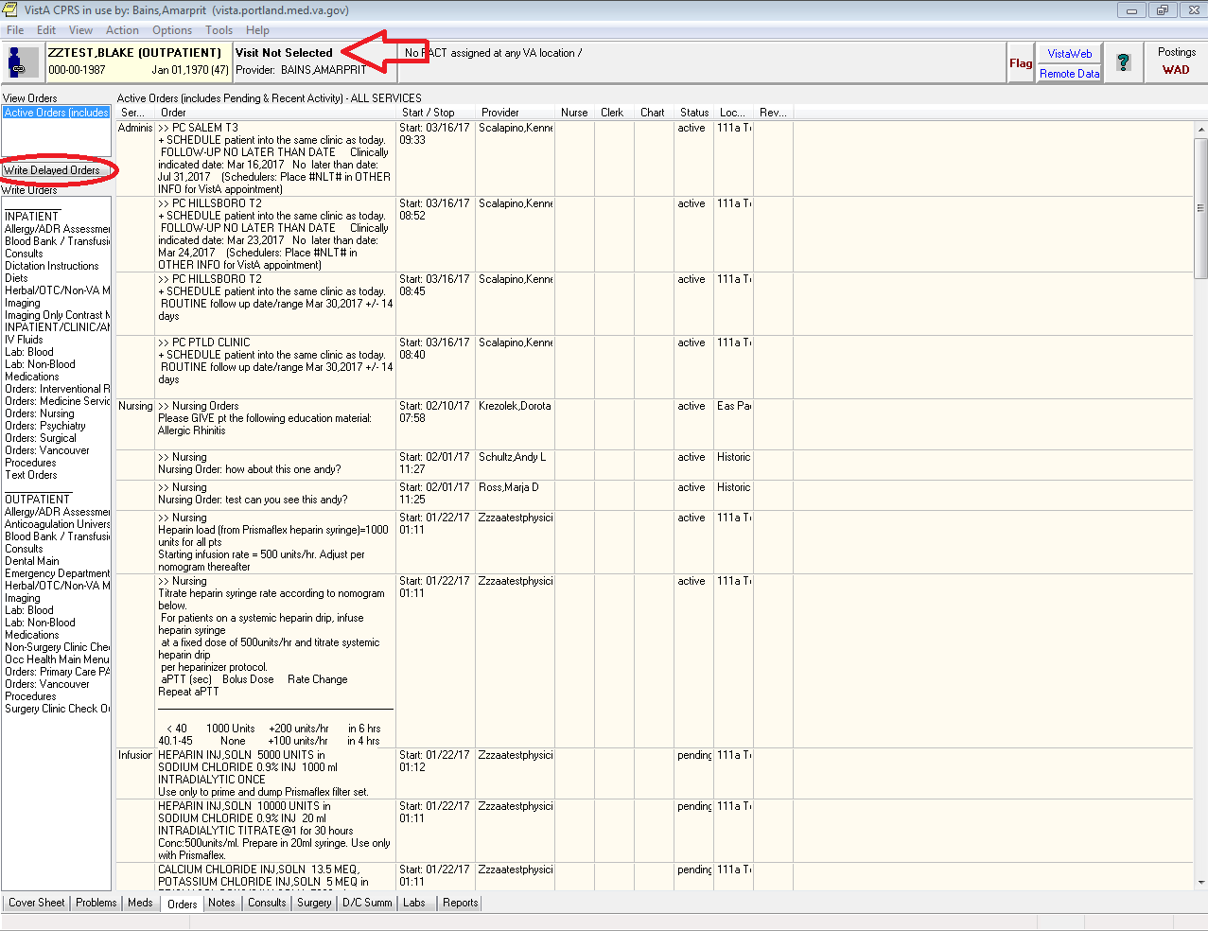
   1. *Red Arrow:*
      1. Notice there are two options here. The first option will make whatever orders you put in go live immediately which is not what we want. Make sure ‘Delay Release of new order(s) until” is clicked
      2. Essentially you are setting up a trigger. You want all the orders you are about to write not to go live until the trigger criteria is met. In this case the criteria is “Admit to [whichever service]
3. **Choose the appropriate service**
   1. Internal Medicine – Admit to General Medicine
   2. Hospitalist Service – Admit to Metabolic
   3. Observation patient – Admit to Medical Observation
   4. ICU – Admit to Medical ICU
4. **When:**
   1. When it prompts you for “When?” you can write whatever you like. I usually write “when bed available.”

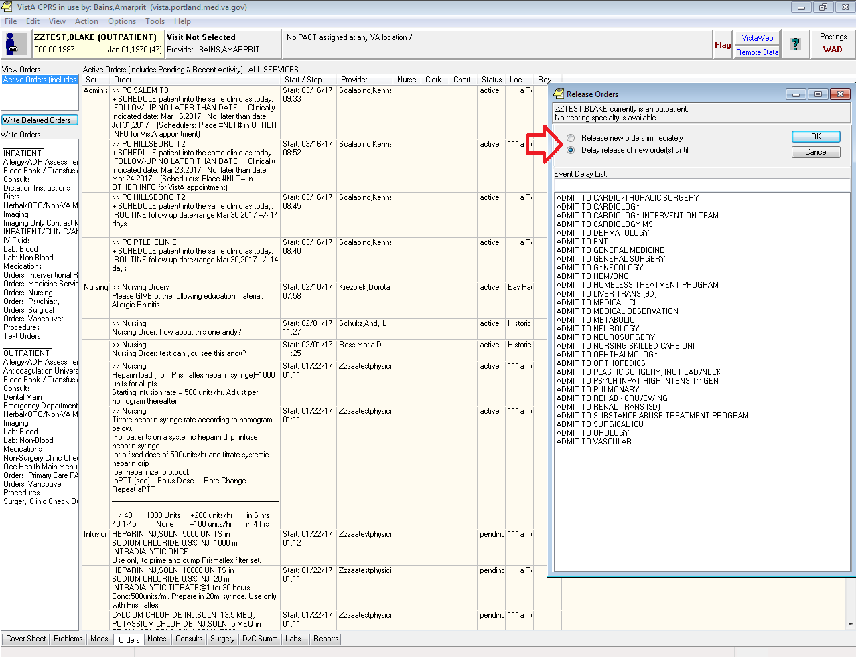

* 1. *Red Arrow:*
     1. Notice how the “Delayed ADMIT TO …” is now highlighted. This means you are now putting in delayed orders.
     2. You can click on the line above it that says “Active Orders” to put in orders that go live immediately
     3. You can switch back and forth between them
     4. This is more useful when writing transfer orders to another service within the hospital (the next section covers this)

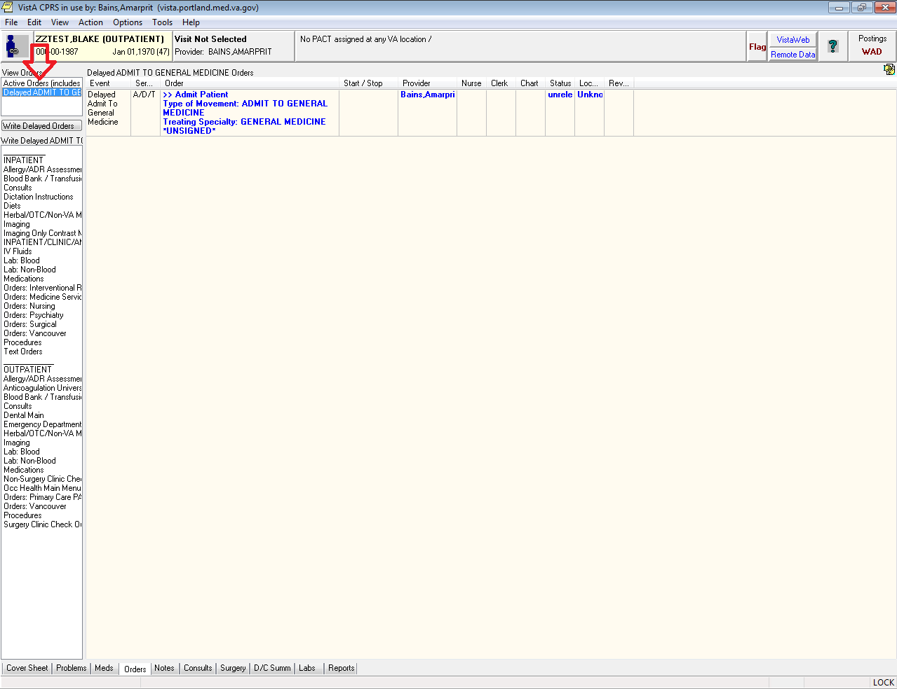

**Writing Delayed Admission Orders**

1. **How to Write Admission Orders**
   1. Write your admission orders here just as you would as if they had just arrived on the floor
   2. Make sure to choose Obs if it is appropriate
   3. It should look something like this:

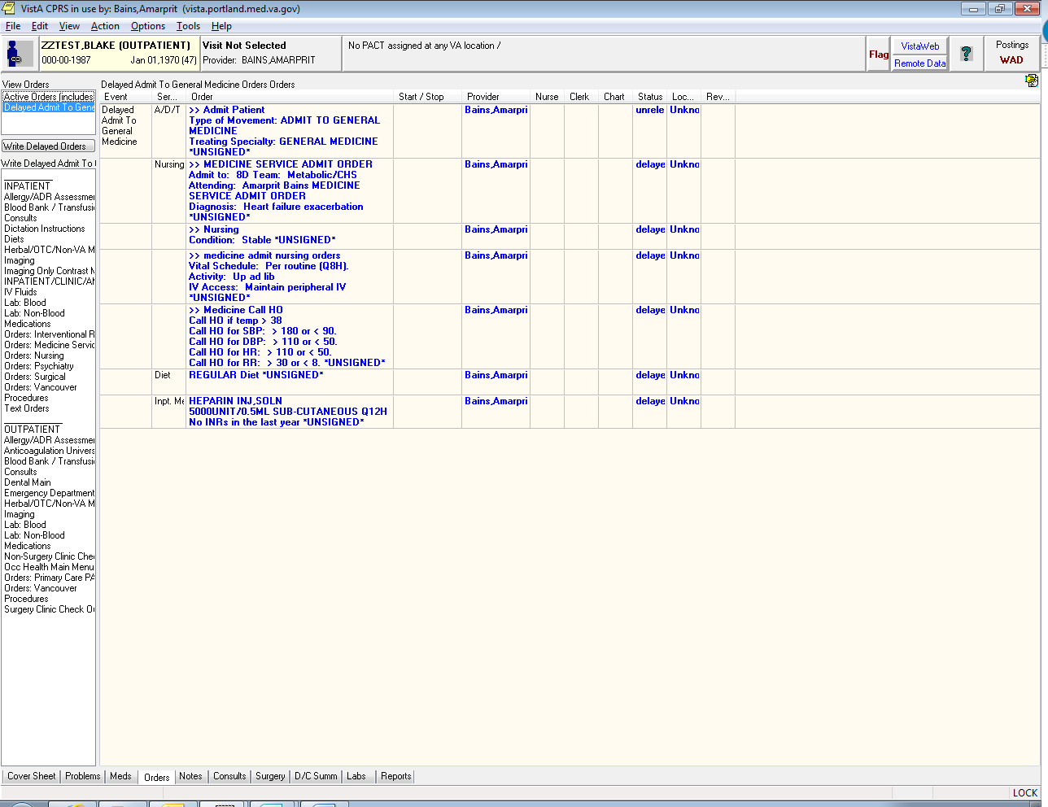

**Transferring in Outpatient Medications**

1. **Go to the ‘Meds’ Tab**
2. **Notice**:
   1. Since this patient is an outpatient the outpatient meds are listed at the top
3. **Highlight which meds you want to move to inpatient**
   1. *Tip*: you can hold the ‘Control’ button and click on multiple meds to select and de-select them
   2. *Tip*: if you click on the 1st medication so that it is selected (has a blue background) you can:
      1. Hold down the ‘Shift’ button and hit the ‘down arrow’ button to select the meds below it. You can also select a group of meds by
      2. Hold down the ‘Shift button’ and click on the last med to select all the ones in-between
4. **Copy to New Order**
   1. *Red Arrow:* Go to the Menu Bar and Click on ‘Actions’ and then on ‘Copy to New Order’

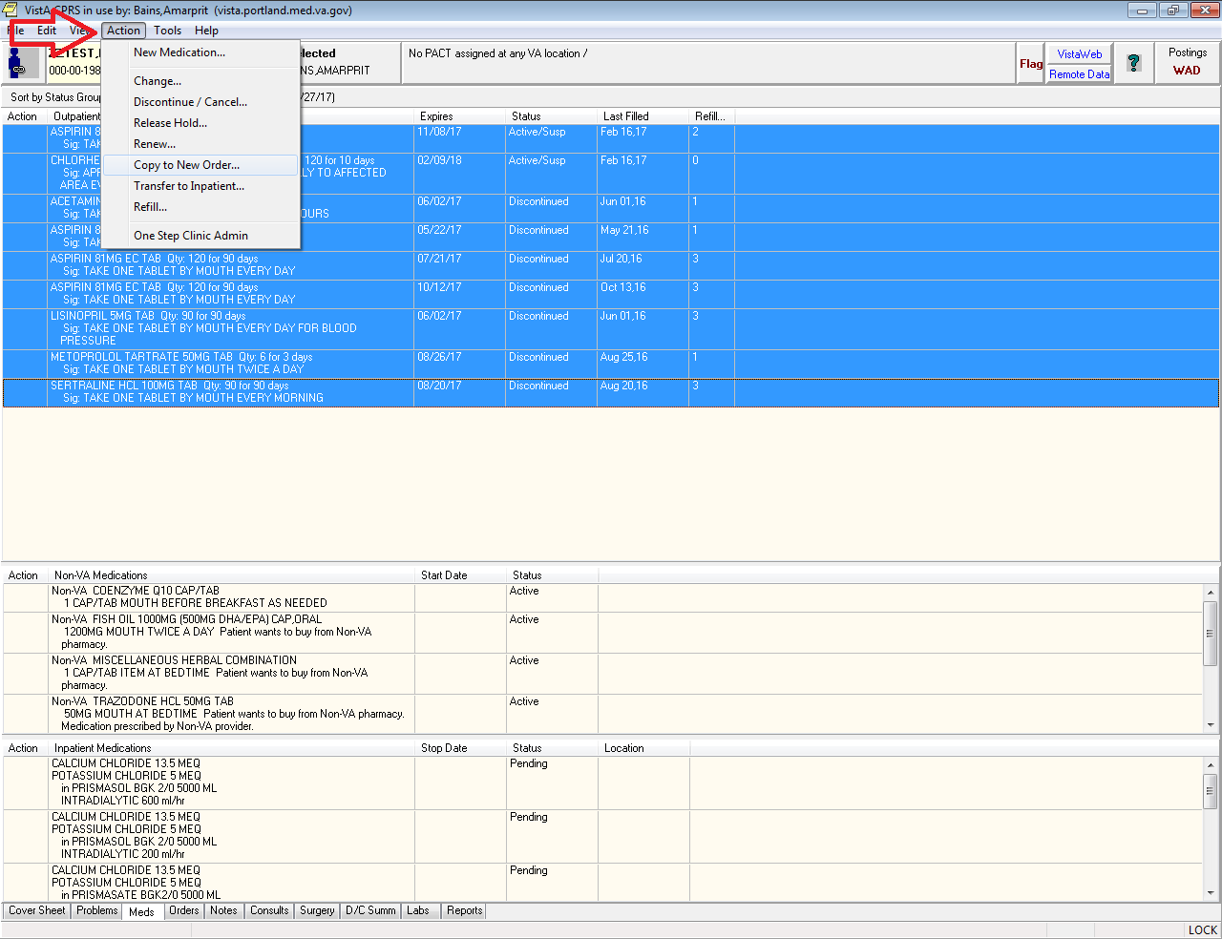

1. **Back to the Delayed Admit Menu**
   1. You’ll notice you go back to the same ‘Delayed Admit’ Orders Menu you saw earlier. Pick the same “Admit to” order you chose earlier.

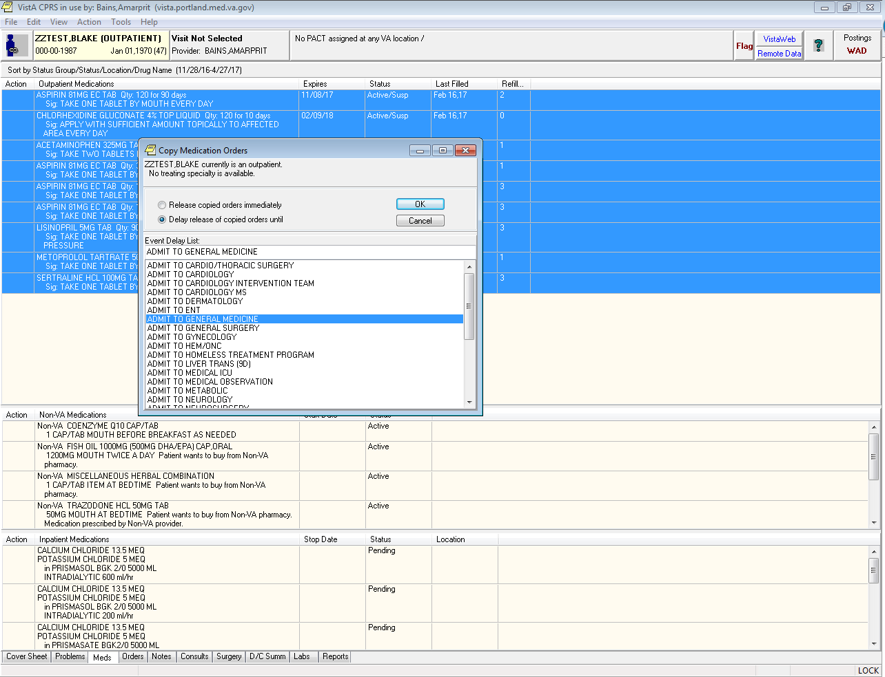

1. **Sign the orders**
   1. Select all the orders and sign them
   2. *Red arrow:*
      1. It prompts you for where these orders will be released. This is the ward the patient will be on.
         1. Type the ward name first. Ex: 9C or 8D or 5C, etc
         2. Choose the right team. For example, a 9C admit to GM2 would be shown as “9CGM2”
         3. Choose either “O” (inpatient admission) or “OBS” (Obs admission) as appropriate. Not every service has the Obs option

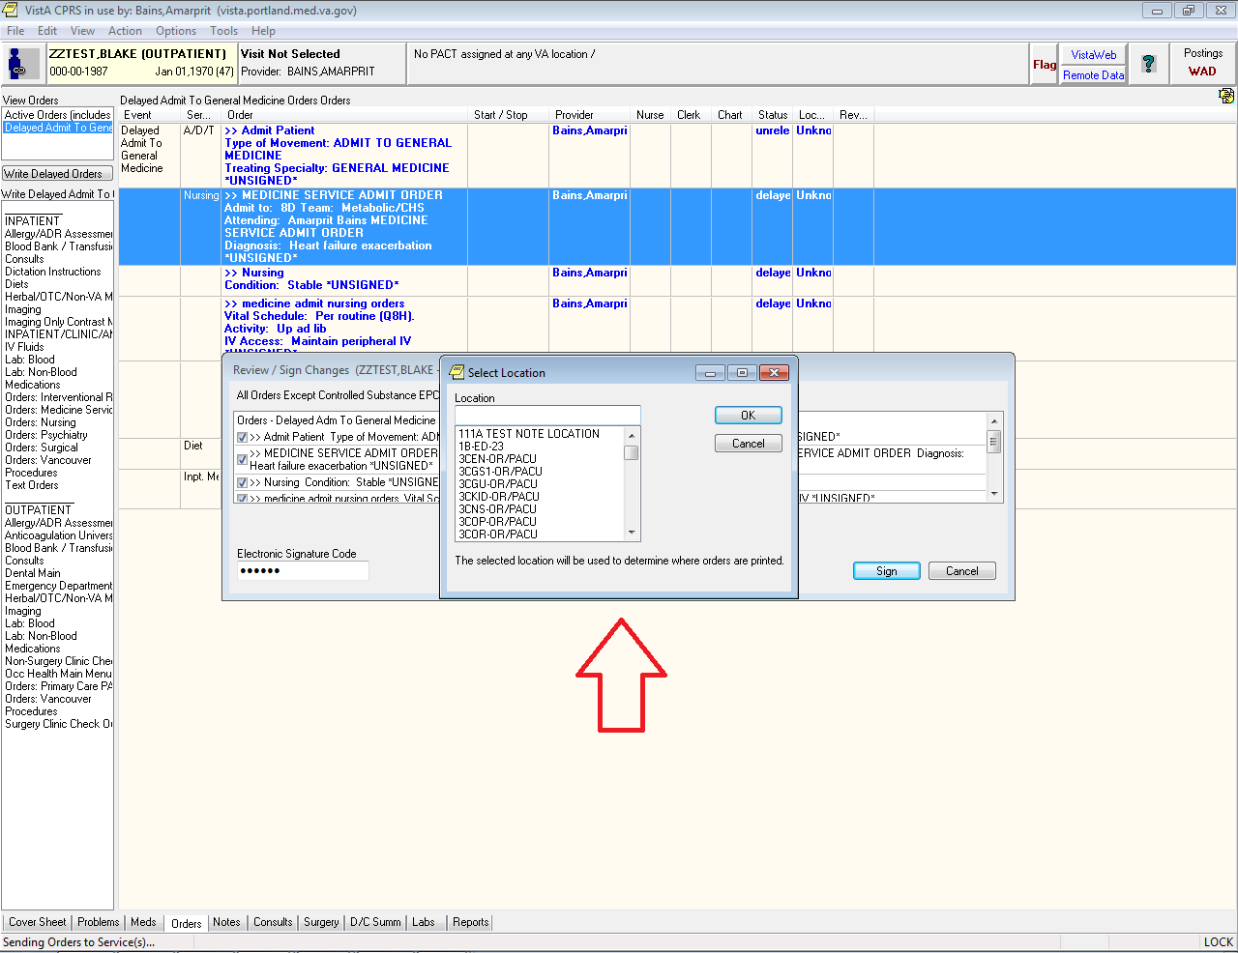

* 1. The screen will refresh and you will now go back to the standard CPRS orders menu.
  2. *Red Arrow:* you can go back to your delayed orders at any time by click on the ‘Delayed Admit To” button.
  3. You can add to your delayed orders later if you want.
  4. To delete your delayed orders highlight everything in the Delayed Orders and choose to discontinue them

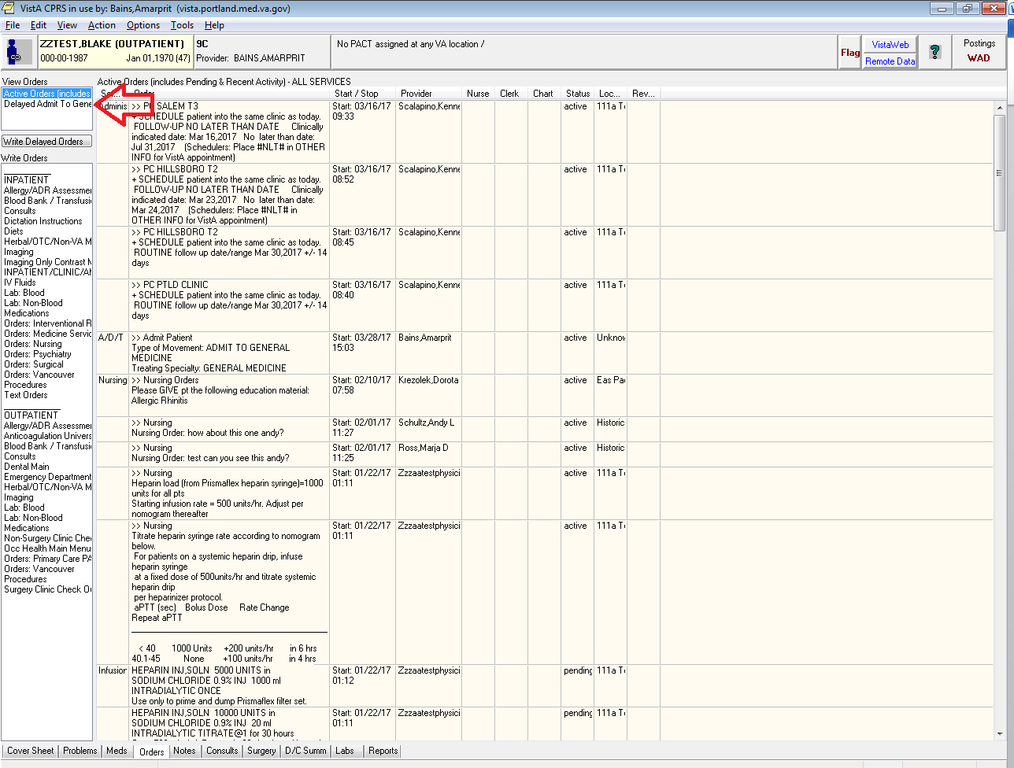

**How to Write Delayed Transfer Orders**

*These are orders that are written for patients currently in the hospital that are temporarily going to another service (like a patient going to the OR and then returning to your team). It is a very useful way to get ahead on your work.*

Criteria:

1. The patient is currently an inpatient

**CREATING A DELAYED TRANSFER ORDER**

1. **Go to the Orders tab**
2. **Click on ‘Write Delayed Orders’**
   1. Notice the menu that pops up is a little different. In this case you now have the option to choose Transfer. Choose the service the patient will be transferring TO.

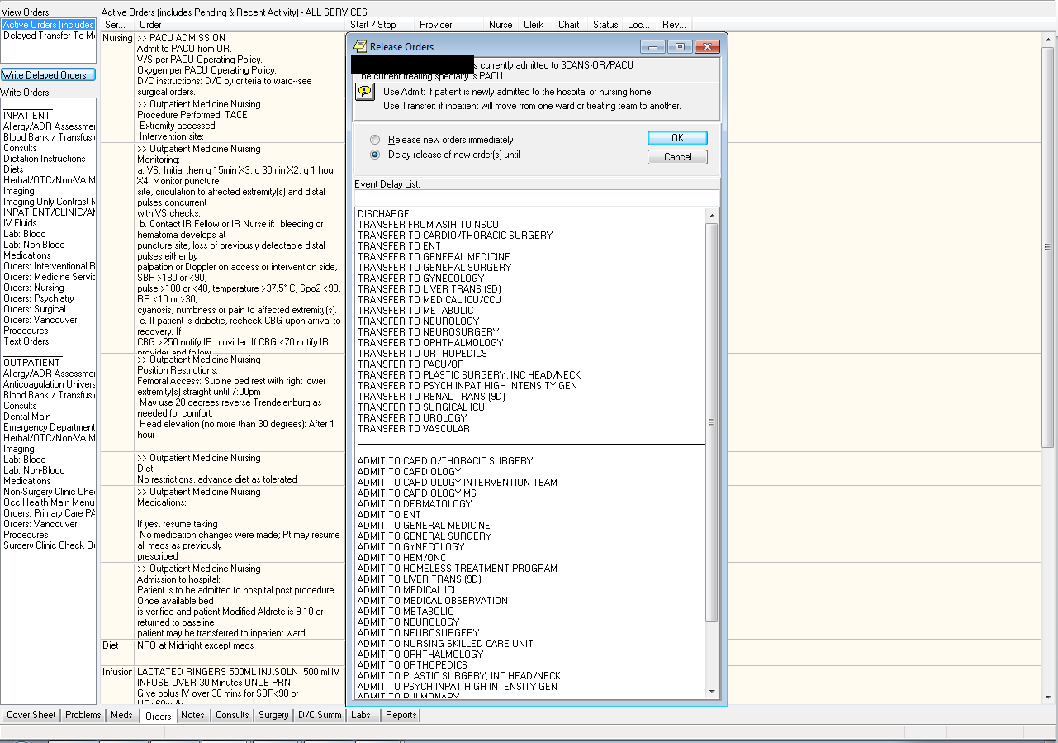

1. **Writing Orders**
   1. As before you’ll see an orders window with just one order.

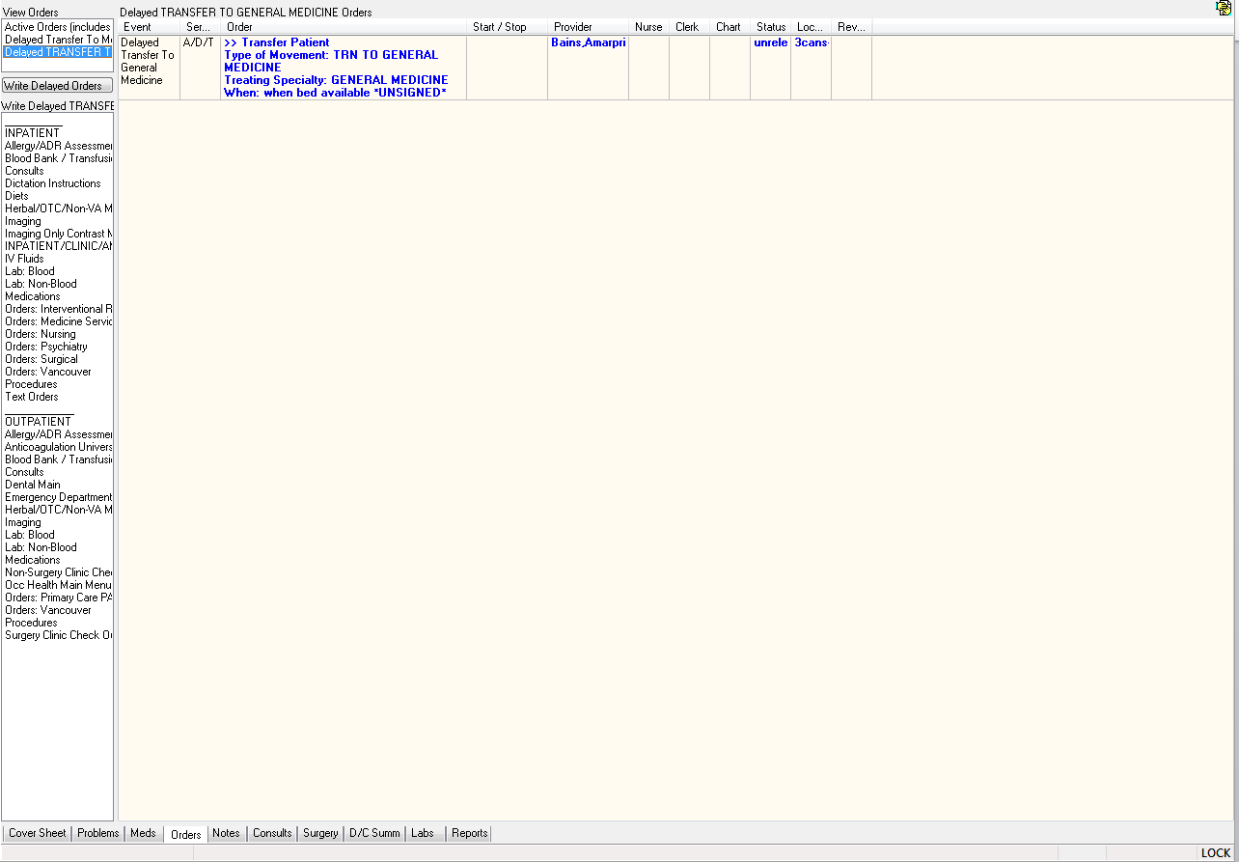

1. **Recovering old orders**
   1. Now, say this patient was on your service and went to the OR and was then coming back to your team. You could manually re-write all your orders but that is a huge pain. There is a much easier way to recover your old orders.
   2. Go to the menu bar and choose ‘View’->’Auto DC/Release Event Orders’
   3. *Tip*: if you want to leave this view go to the menu bar and choose ‘View’->’Return to default view’

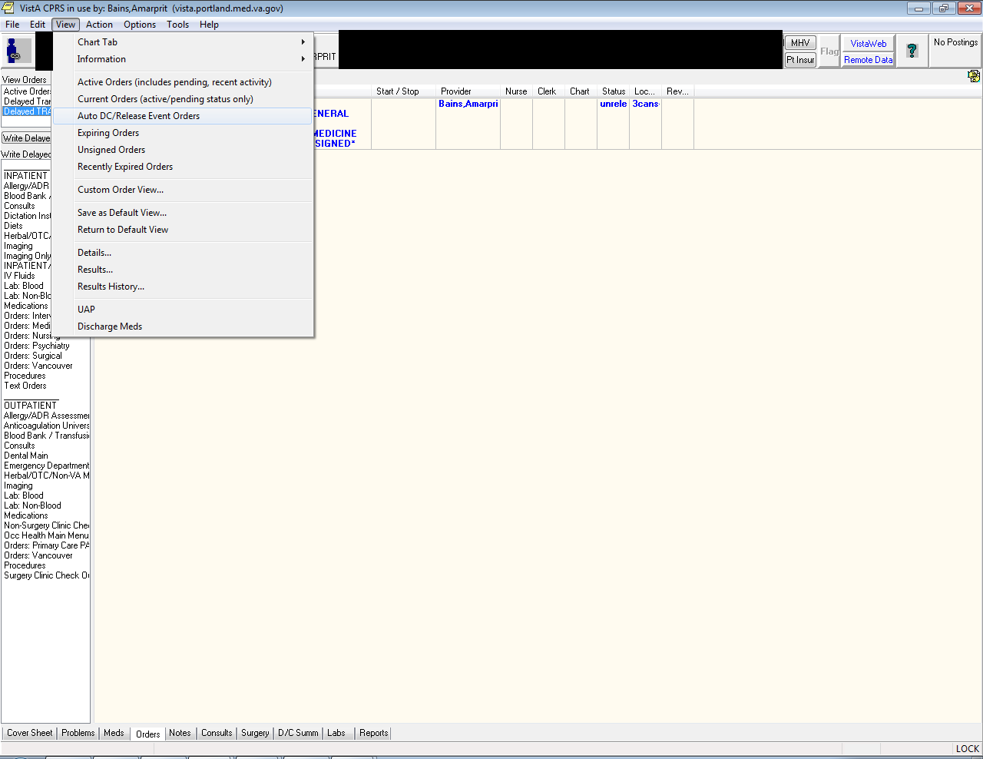

* 1. It will bring up this little window. This window shows every time the patient has been either admitted or transferred for the specified number of events.
     1. The most recent event is at the top
     2. In the example below I have chosen to show the last two events. As you can see it shows the patient was admitted to Metabolic Service (The Hospitalist Service) and then had a “Treating Specialty Change” (went to the OR).

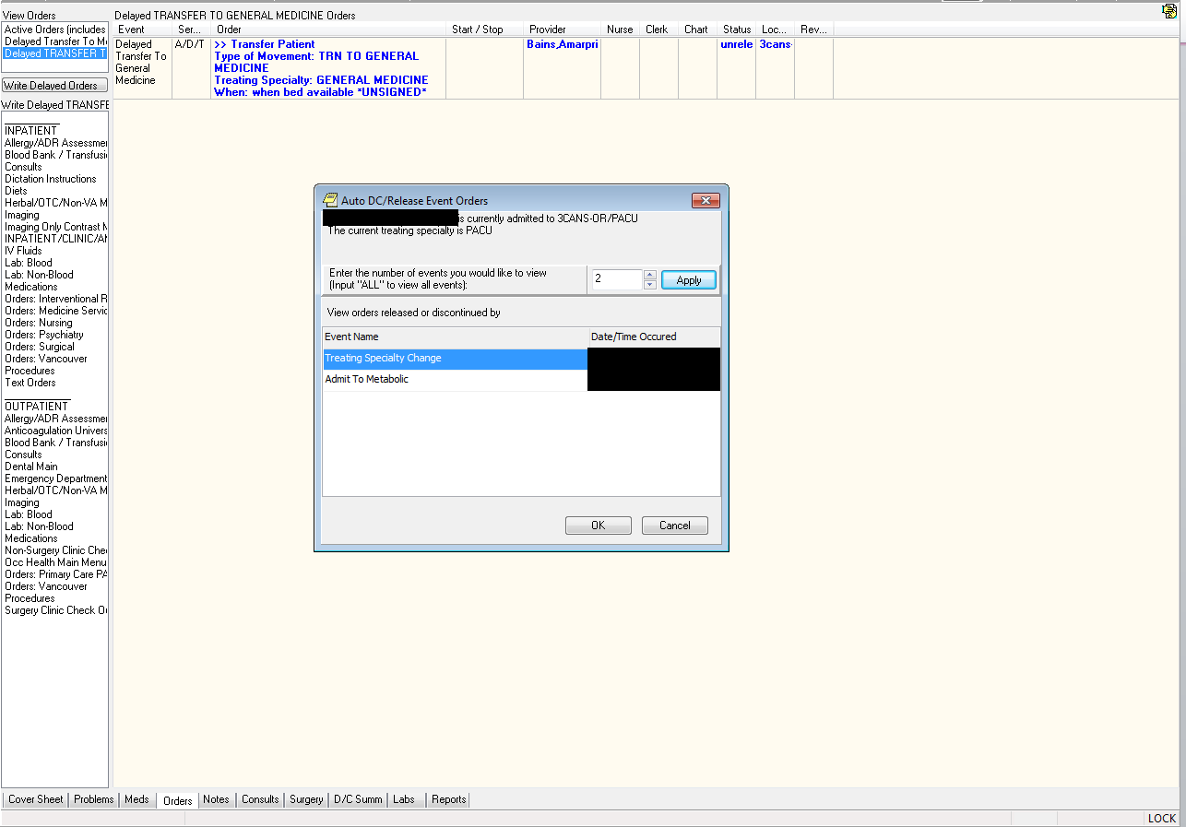

* 1. If I select “Treating Specialty Change’ and hit “OK” it will bring up all the orders that were active before the patient went to the OR.
  2. *Red Arrow:* Notice they are all “discontinued” (as they should be).

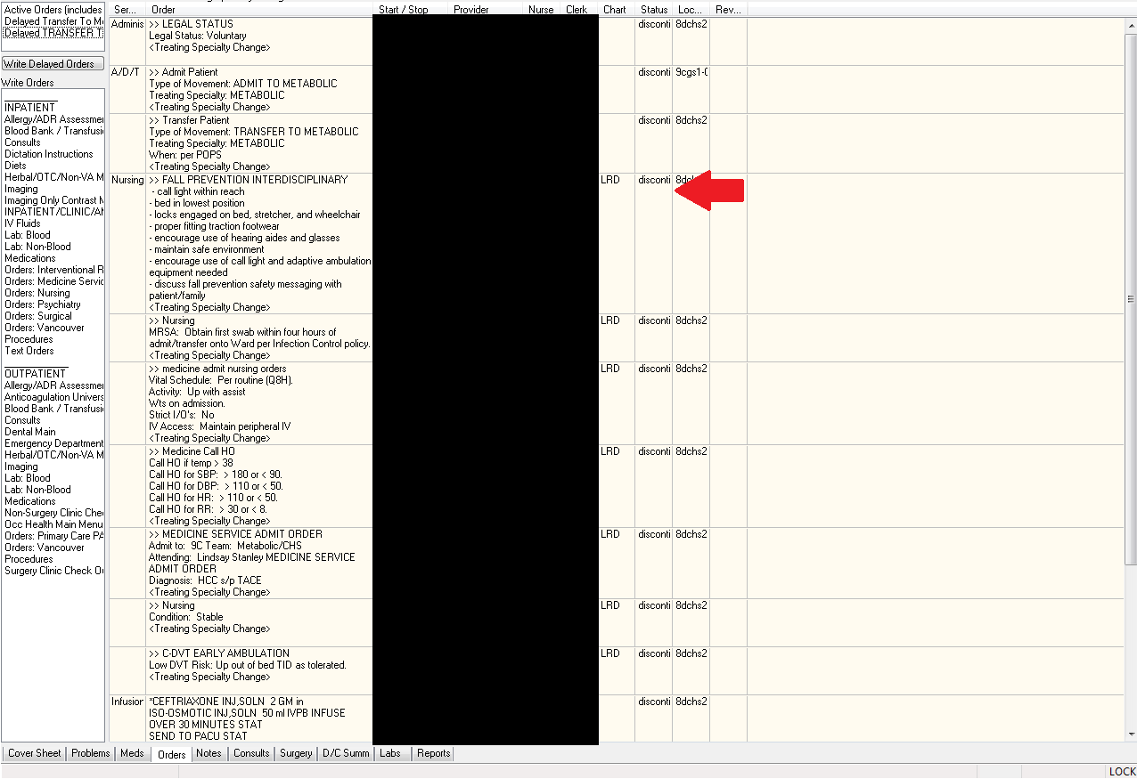

* 1. Select all the orders you want and, on the menu bar, choose ‘Action->Copy To New Order’

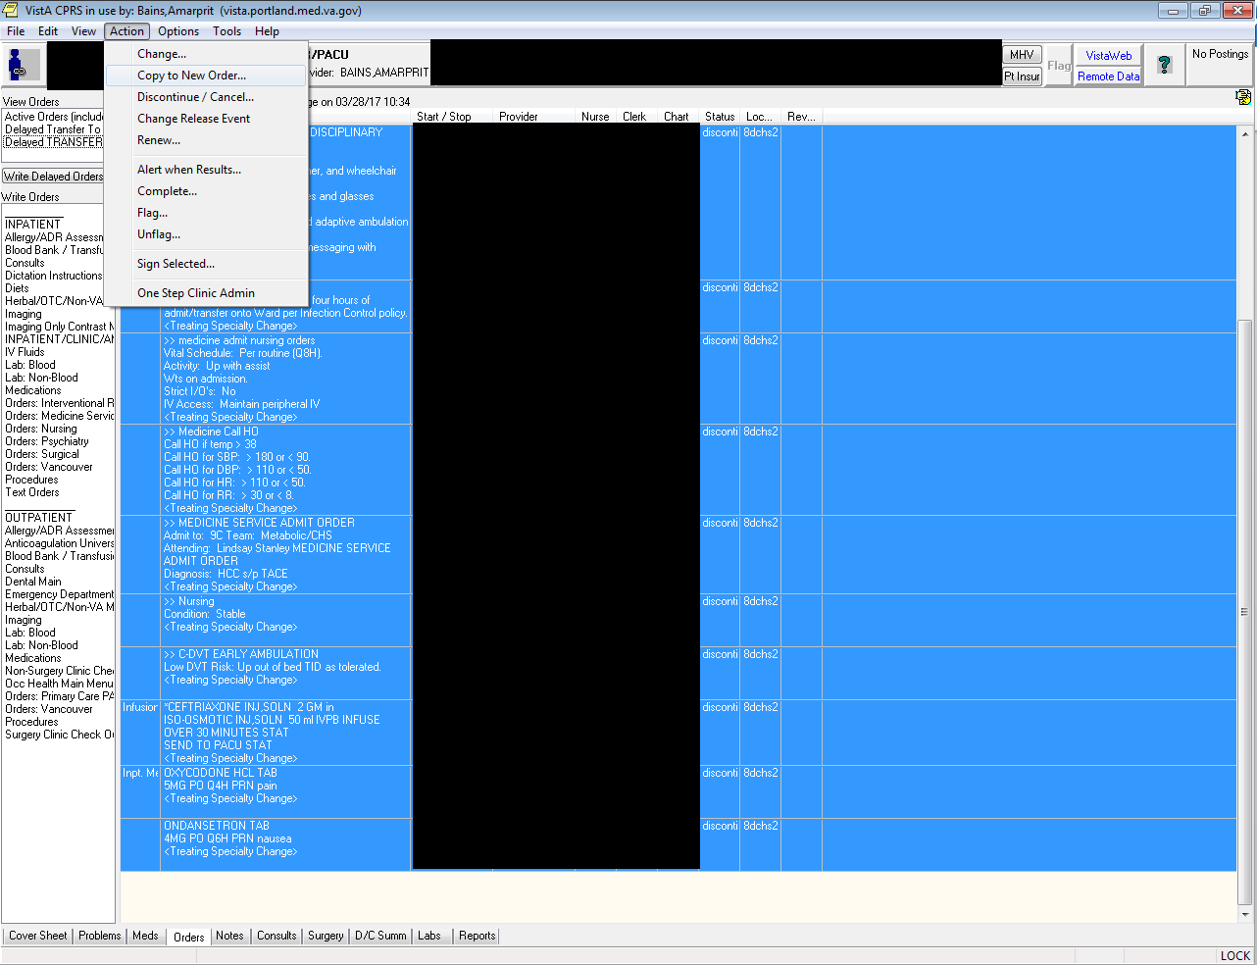

1. Click on the “Delay release of copied orders” radio button and choose the appropriate service to Transfer back TO. This should be the same one you chose before
   1. *Tip*: you can, if you want, start at the Auto Release/DC step and go from there. It will create a new Transfer Order for you

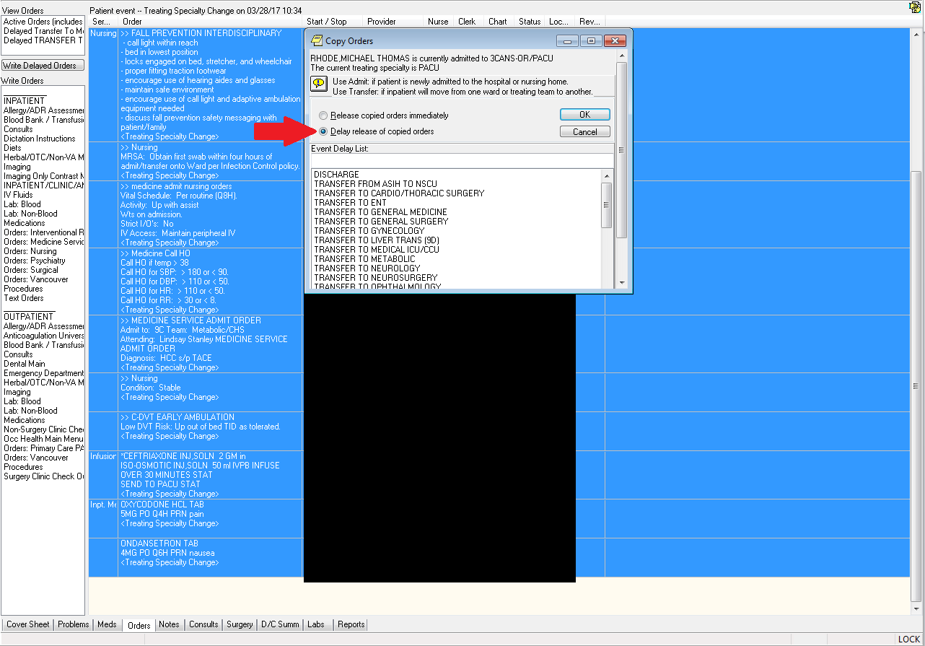

1. **Sign all the orders and you’re done**
   1. They’ll go active when the patient transfers back.

Return to the Tab by Tab Training

**Consults: How to communicate significant findings to PCPs**

It is critical that anyone who is involved in **CONSULT MANAGEMENT in CPRS** be aware of this change. Timely communication impacting Veteran care and safety are at stake. A recent VHA effort to reduce CPRS alert fatigue promoted Primary Care providers to turn off an option in CPRS that generates a CPRS ALERT anytime someone uses "ADD COMMENT" on a consult.

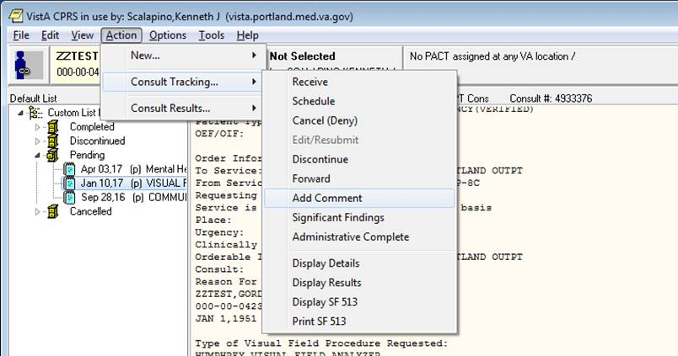

What you must know:

1. As the CPRS option to see “ADD COMMENT” alerts has always been optional, **NO DHSM PERSONNEL SHOULD RELY ON THIS FOR CRITICAL COMMUNICATION**.
2. Our Nurse Care Coordinators and Facilitators will leave this notification system on and your internal team communication around consult management should still work, but you **CANNOT USE “ADD COMMENT” TO REQUEST INFORMATION FROM THE ORDERING PROVIDER (AT LEAST IN PRIMARY CARE) AS THEY WILL NOT SEE IT**.
3. Effective immediately, for any critical communication by DHSM staff to the ordering provider, you must now use the “**SIGNIFICANT FINDINGS**” option as this is not blocked by the change (There are limitations to this method as well that will be explained further in the near future).

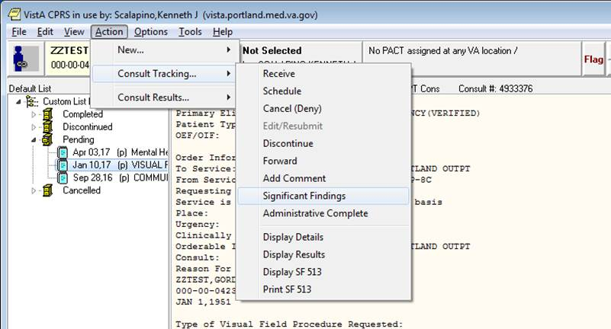

The “SIGNIFICANT FINDINGS” window has options around the current status, but you can pick anything if you are just using this to reach the PCP with an important request in support of the consult.

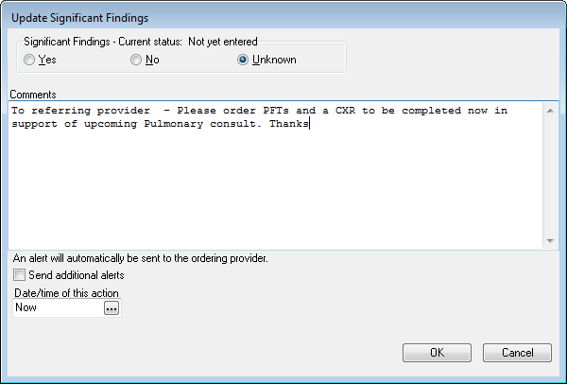

1. In DHSM we are also very concerned about CPRS Alert fatigue, but as we receive consult from across the VISN and there is yet to be a consistent VISN20 wide policy around this critical issue, if you are involved in consult triage and scheduling and turn off your notification flag, there is a significant risk someone within the Portland system or from another VISN20 VA will try to use “ADD COMMENT” to alert you to something. As the CPRS user has no way to know how your notification flag is set, this creates risk. DHSM continues to strongly advocate for a VISN wide practice and will keep you updated.

Return to the Tab by Tab Training