Creating a discharge summary with the correct template
The default discharge summary template is NOT the one that you should be using. It will eventually be replaced with the template below. For now, follow the instructions below to find the proper template.

- Go to the discharge summary tab and select ‘New Summary’
  - Red Arrow: Location of the Discharge Summary tab
  - Blue Arrow: How to create a new discharge summary
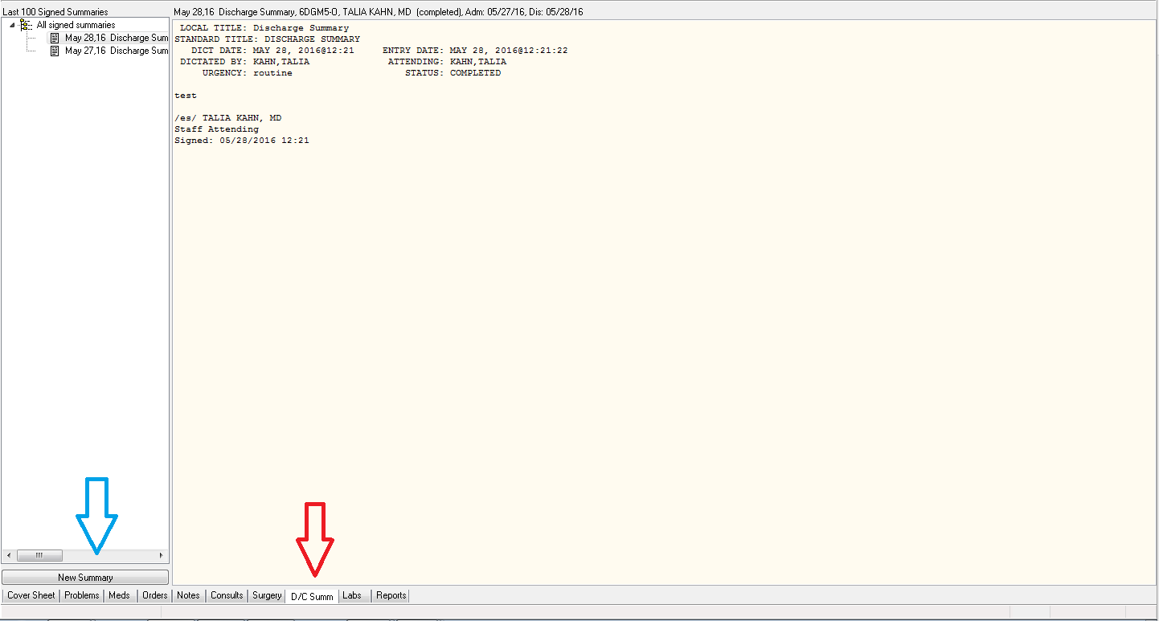

- Creating the discharge summary
  - Any note title will work. You can just choose the top one ‘DCS <DISCHARGE SUMMARY>’
  - Red Arrow: Fill in the name of your attending here
  - Blue Arrow: choose the associated admission for the summary
    - Note: if the patient was converted from Obs to inpatient there will be two admission dates
      - The first is for when the patient was discharged from Obs and admitted
        - This discharge summary can be very brief and can instruct people to refer to inpatient discharge summary
      - The second is for when the patient was discharged from the inpatient service
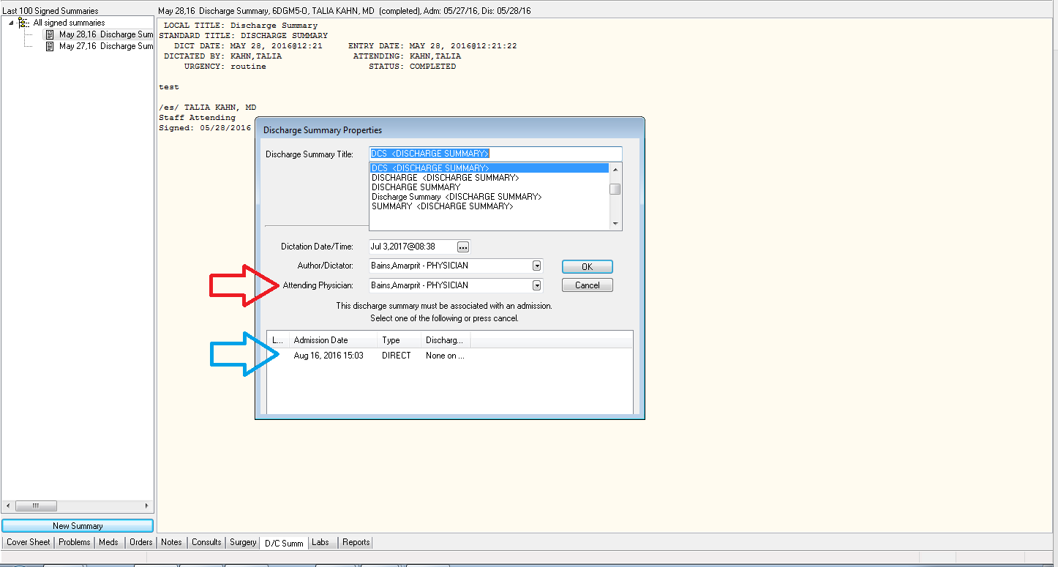
- The default template will appear
  - Red Arrow: hit OK and then delete all the text that appears
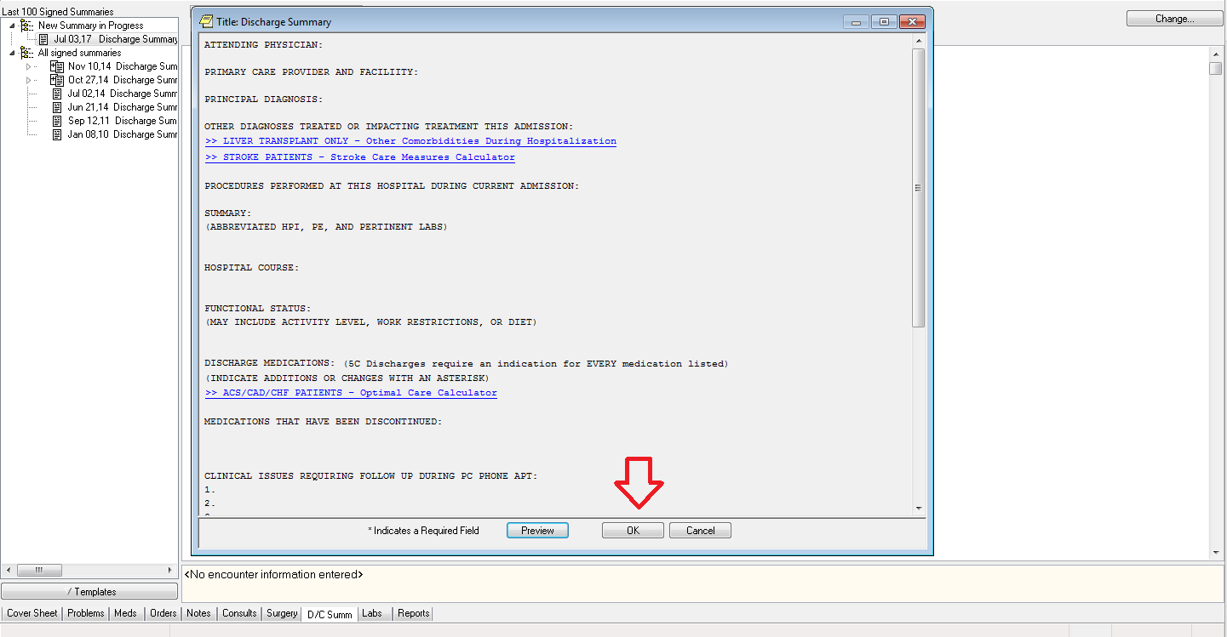
- Now that you have an empty note you can add the proper template
  - Red Arrow: Click on the Templates button
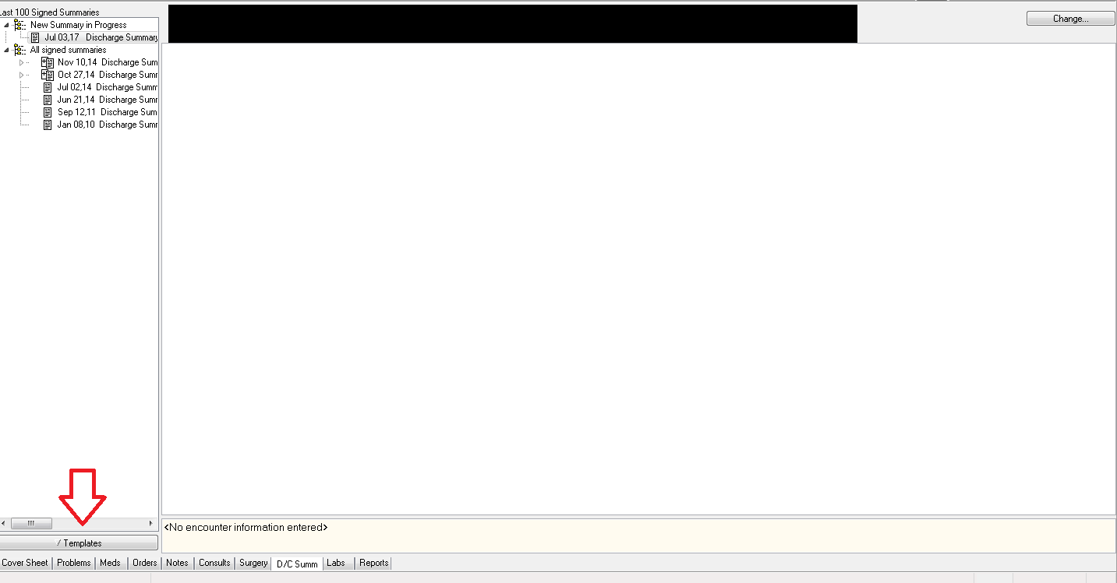
- The proper discharge summary template is in the shared templates section
  - Red Arrow: choose ‘Shared Templates.’ Click on the little triangle to expand the list
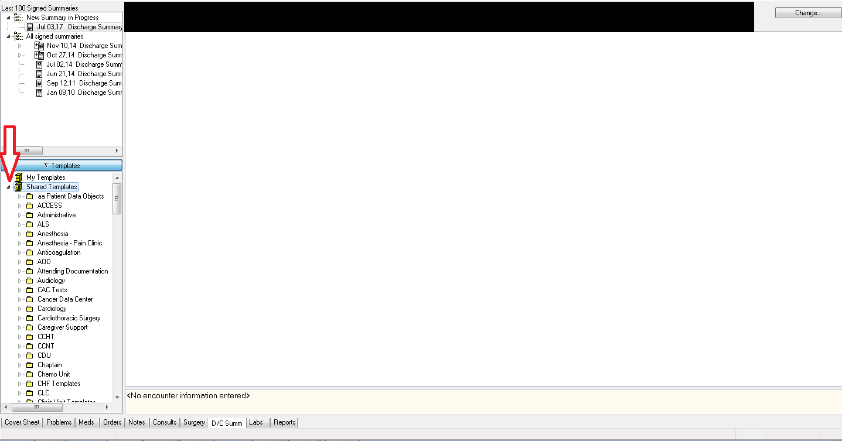

- Finding the folder with the template
  - Red Arrow: Go to ‘NWIC’->’Discharge Process (Segura/Hunsaker)’->’Discharge Summary (2015’
  - Either double click or drag and drop it into the discharge summary area
