How to Write Delayed Orders (Pre-admit and Transfer orders)
Delayed admit orders are orders that are written before a patient is admitted to the hospital and go live the moment the patient arrives on the floor. It is a very useful way to get ahead on your work.
Criteria:
- The patient is currently an outpatient
- You know which ward the patient will be admitted to
Delayed transfer orders are for patients already in the hospital and moving from one subspecialty to another.

Creating a Delayed Admission Order
- Go to the Orders tab
  - Red Arrow:
    - It shows the patient’s status as “Visit Not Selected.” This means he is currently an outpatient and is appropriate for delayed admit orders
- Click on ‘Write Delayed Orders’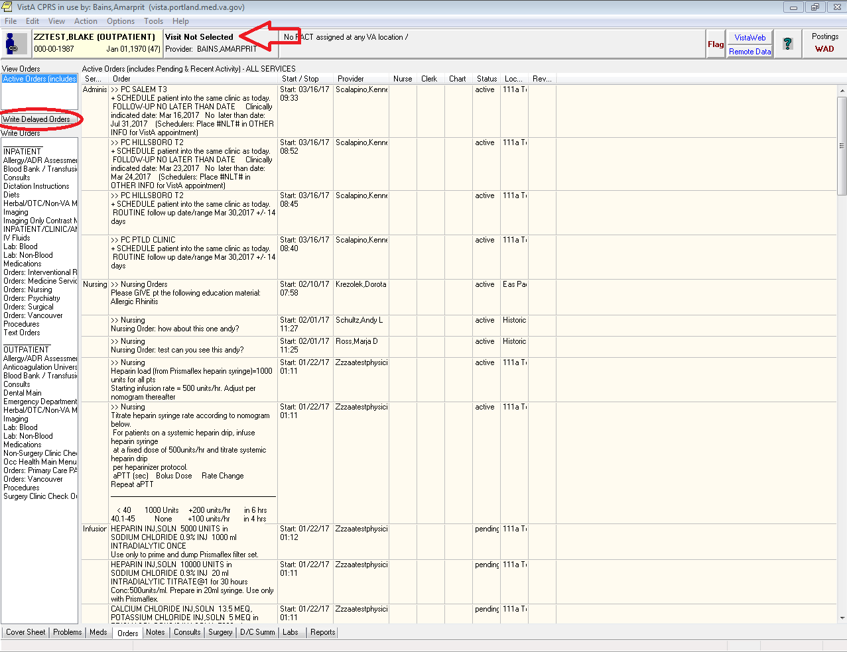
  - Red Arrow:
    - Notice there are two options here. The first option will make whatever orders you put in go live immediately which is not what we want. Make sure ‘Delay Release of new order(s) until” is clicked
    - Essentially you are setting up a trigger. You want all the orders you are about to write not to go live until the trigger criteria is met. In this case the criteria is “Admit to [whichever service]
- Choose the appropriate service
  - Internal Medicine – Admit to General Medicine
  - Hospitalist Service – Admit to Metabolic
  - Observation patient – Admit to Medical Observation
  - ICU – Admit to Medical ICU
- When:
  - When it prompts you for “When?” you can write whatever you like. I usually write “when bed available.”
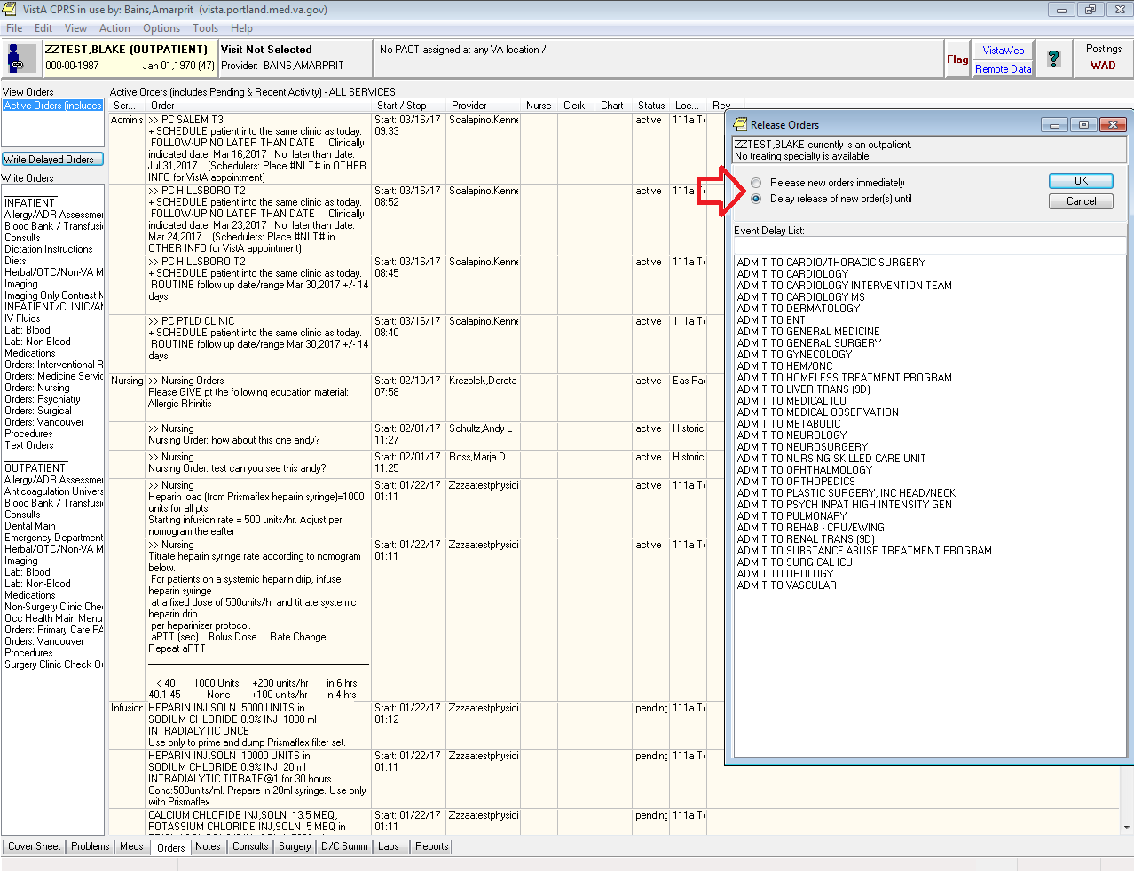

  - Red Arrow:
    - Notice how the “Delayed ADMIT TO …” is now highlighted. This means you are now putting in delayed orders.
    - You can click on the line above it that says “Active Orders” to put in orders that go live immediately
    - You can switch back and forth between them
    - This is more useful when writing transfer orders to another service within the hospital (the next section covers this)

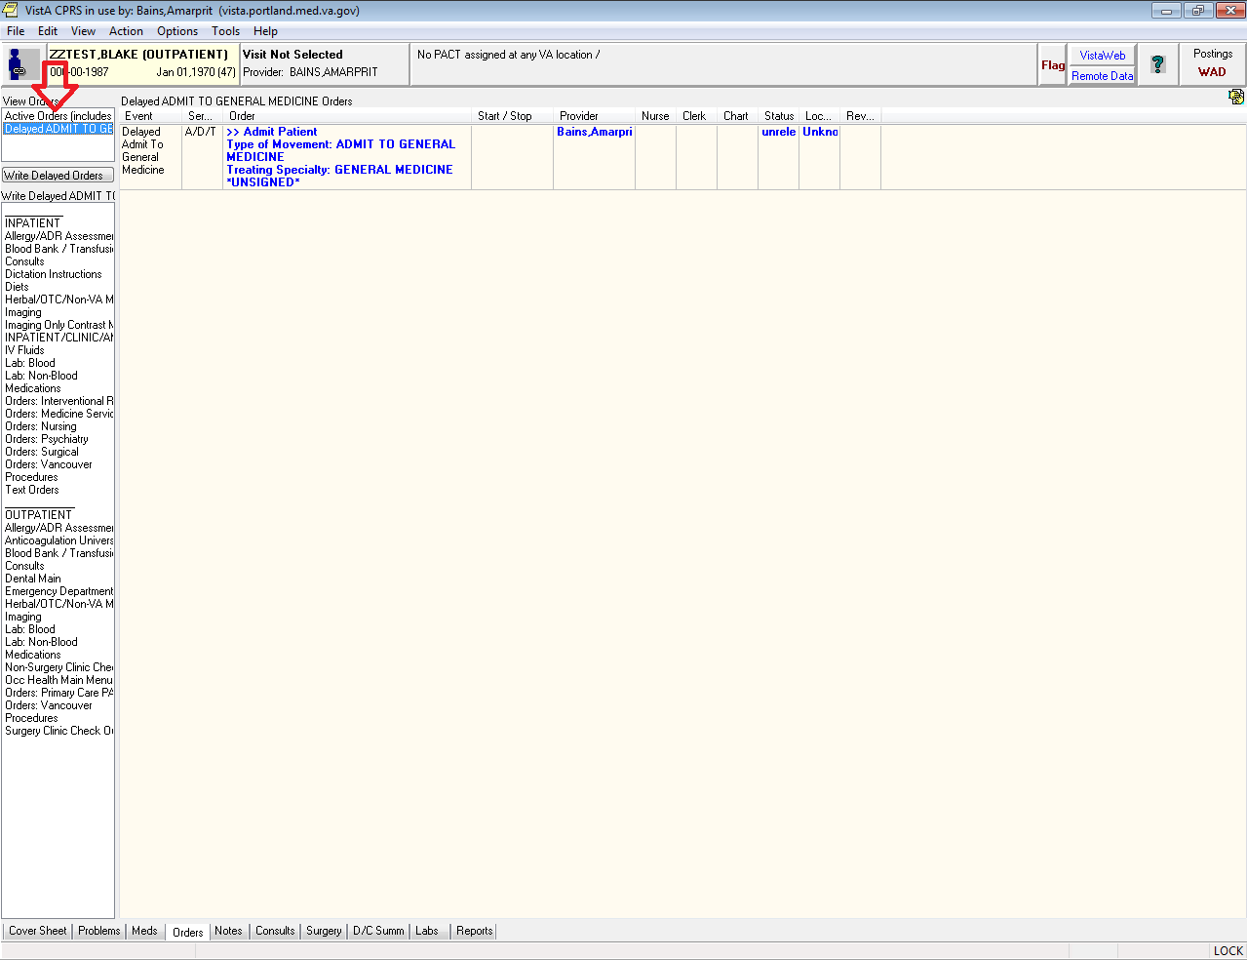

Writing Delayed Admission Orders
- How to Write Admission Orders
  - Write your admission orders here just as you would as if they had just arrived on the floor
  - Make sure to choose Obs if it is appropriate
  - It should look something like this:
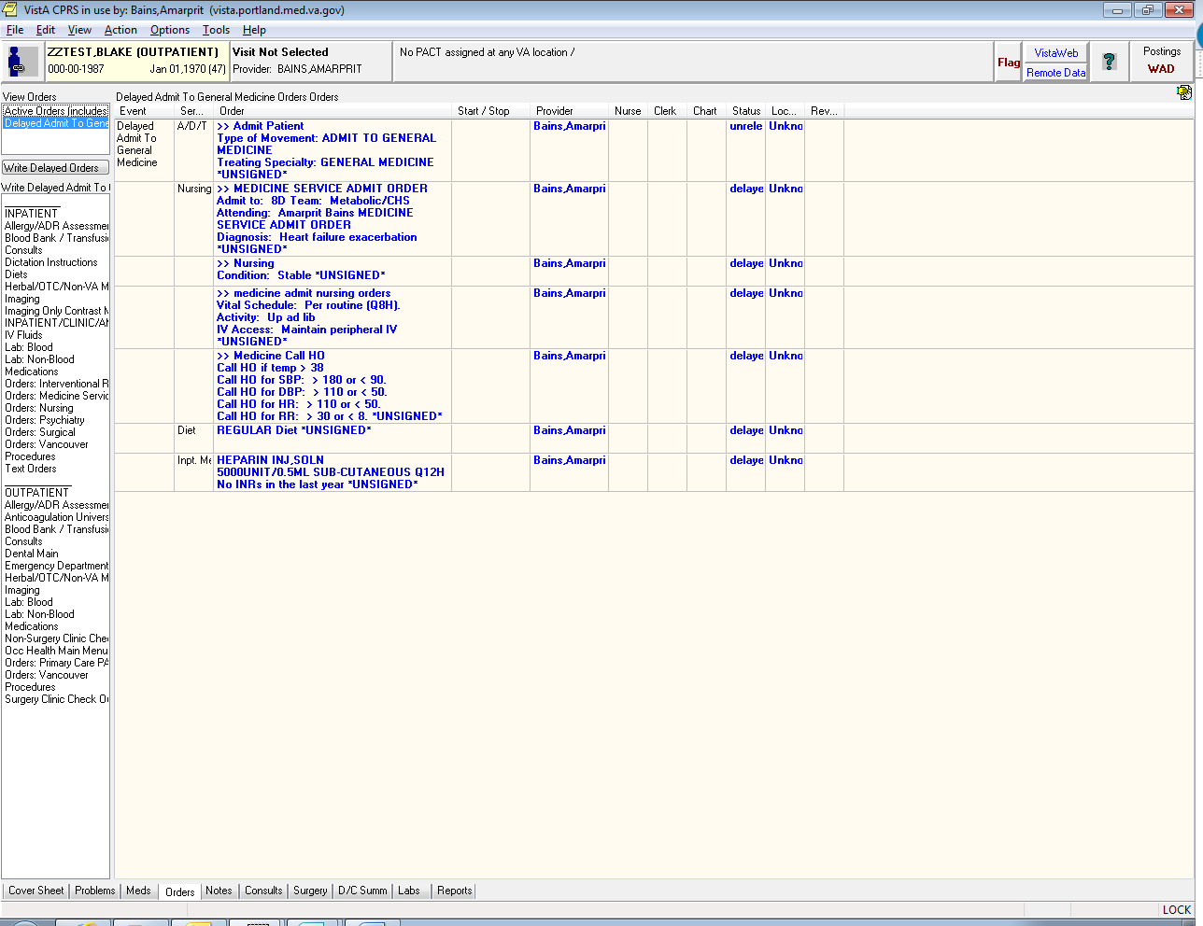

Transferring in Outpatient Medications
- Go to the ‘Meds’ Tab
- Notice:
  - Since this patient is an outpatient the outpatient meds are listed at the top
- Highlight which meds you want to move to inpatient
  - Tip: you can hold the ‘Control’ button and click on multiple meds to select and de-select them
  - Tip: if you click on the 1st medication so that it is selected (has a blue background) you can:
    - Hold down the ‘Shift’ button and hit the ‘down arrow’ button to select the meds below it. You can also select a group of meds by
    - Hold down the ‘Shift button’ and click on the last med to select all the ones in-between
- Copy to New Order
  - Red Arrow: Go to the Menu Bar and Click on ‘Actions’ and then on ‘Copy to New Order’
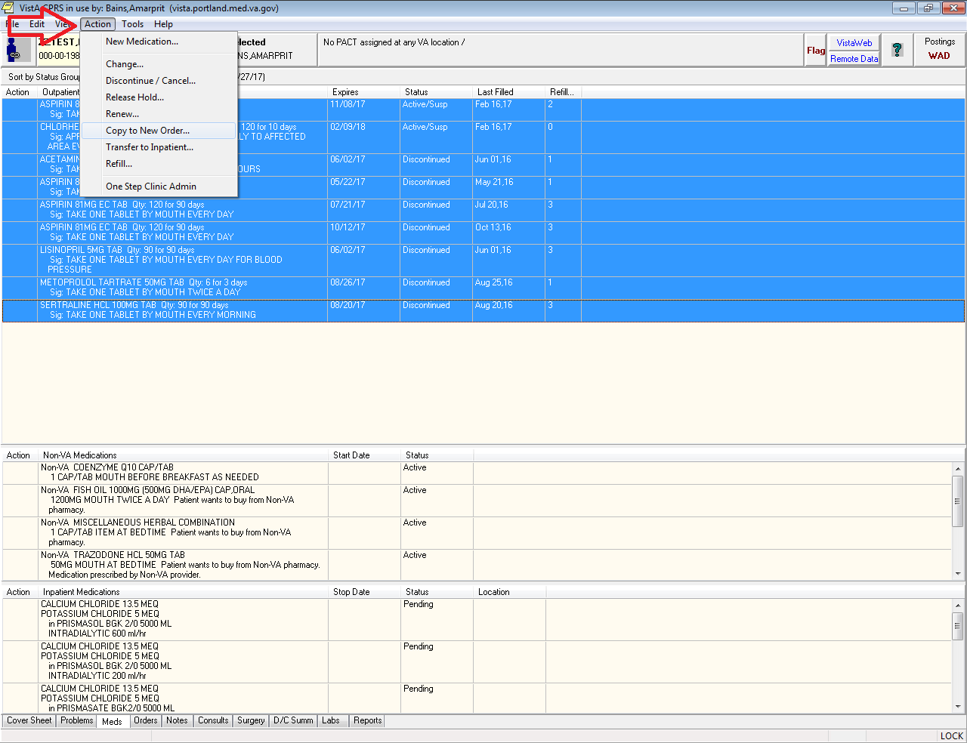

- Back to the Delayed Admit Menu
  - You’ll notice you go back to the same ‘Delayed Admit’ Orders Menu you saw earlier. Pick the same “Admit to” order you chose earlier.
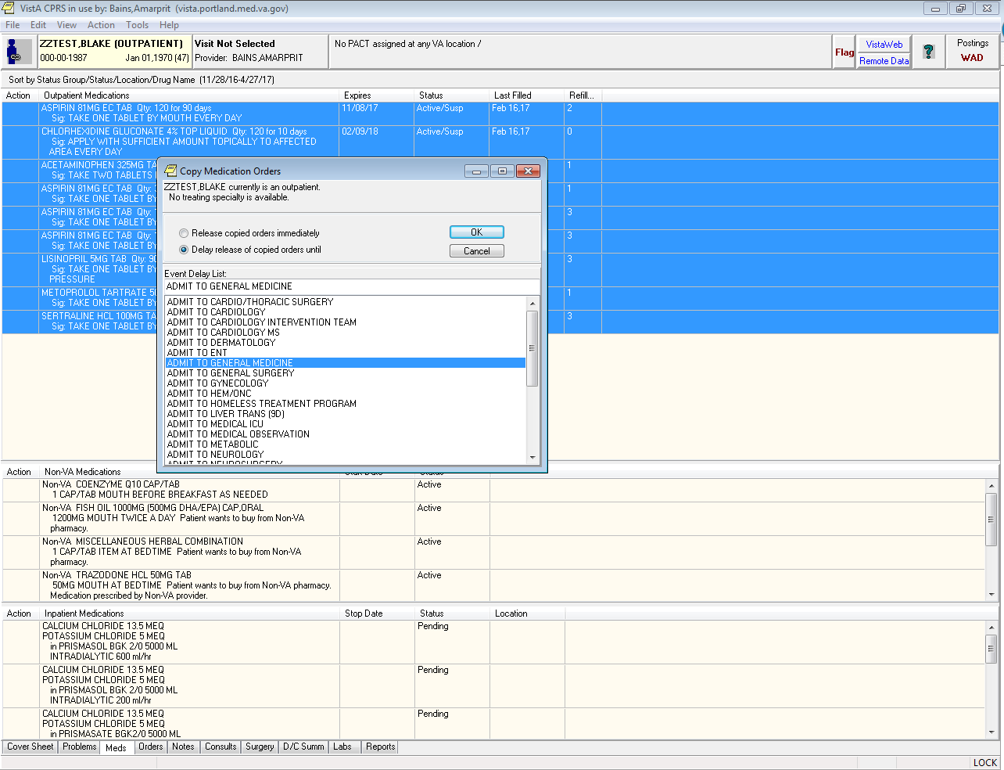
- Sign the orders
  - Select all the orders and sign them
  - Red arrow:
    - It prompts you for where these orders will be released. This is the ward the patient will be on.
      - Type the ward name first. Ex: 9C or 8D or 5C, etc
      - Choose the right team. For example, a 9C admit to GM2 would be shown as “9CGM2”
      - Choose either “O” (inpatient admission) or “OBS” (Obs admission) as appropriate. Not every service has the Obs option
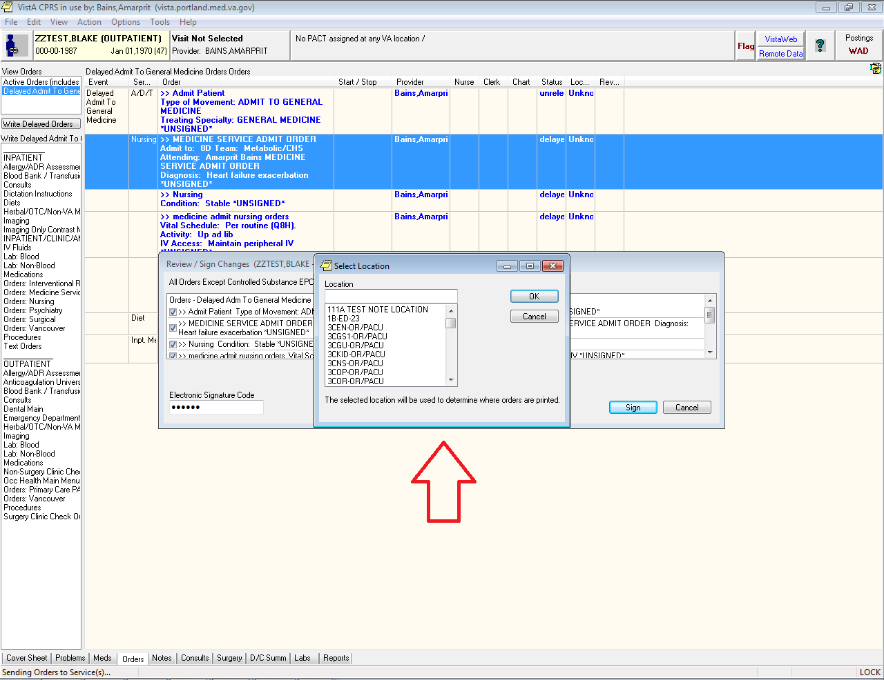

  - The screen will refresh and you will now go back to the standard CPRS orders menu.
  - Red Arrow: you can go back to your delayed orders at any time by click on the ‘Delayed Admit To” button.
  - You can add to your delayed orders later if you want.
  - To delete your delayed orders highlight everything in the Delayed Orders and choose to discontinue them

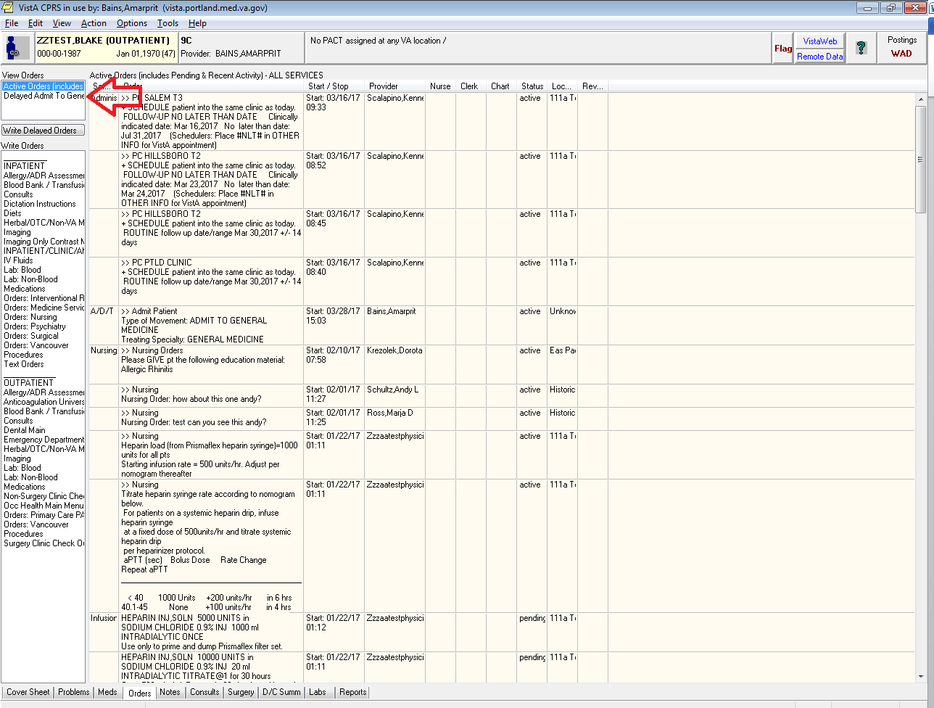

How to Write Delayed Transfer Orders
These are orders that are written for patients currently in the hospital that are temporarily going to another service (like a patient going to the OR and then returning to your team). It is a very useful way to get ahead on your work.
Criteria:
- The patient is currently an inpatient

CREATING A DELAYED TRANSFER ORDER
- Go to the Orders tab
- Click on ‘Write Delayed Orders’
  - Notice the menu that pops up is a little different. In this case you now have the option to choose Transfer. Choose the service the patient will be transferring TO.
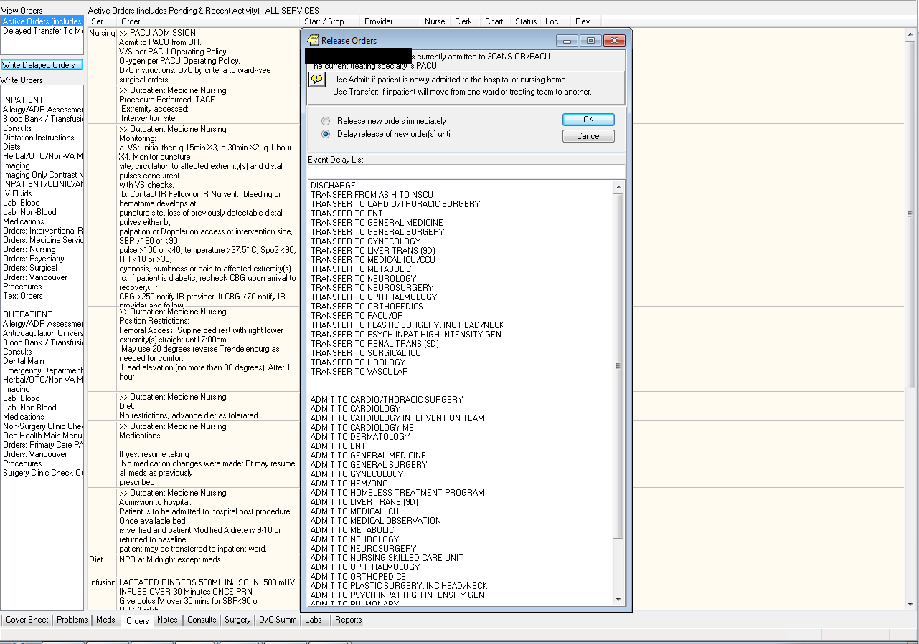

- Writing Orders
  - As before you’ll see an orders window with just one order.
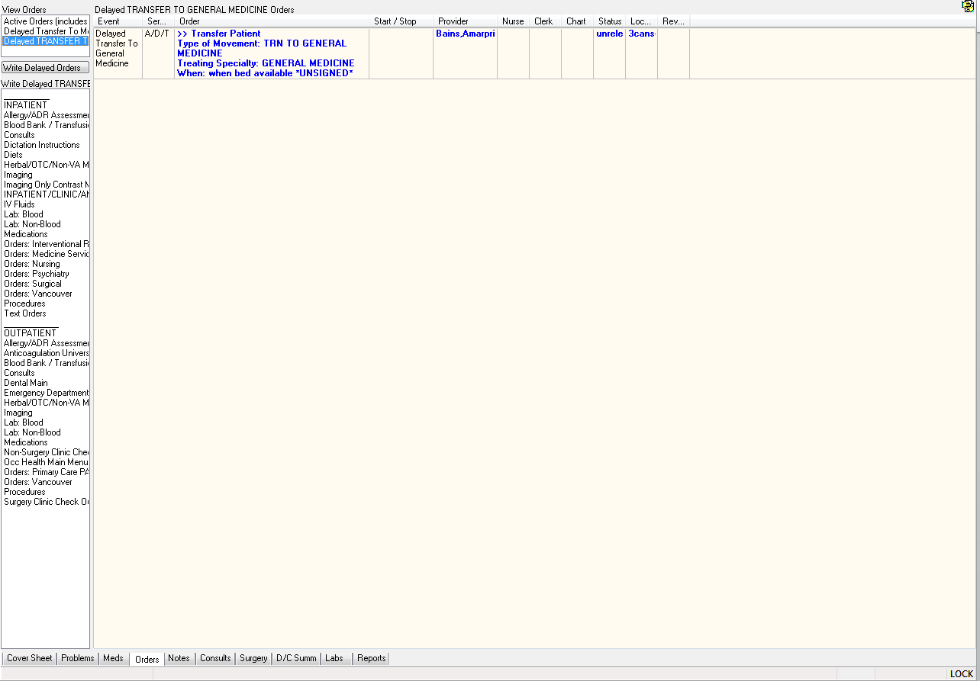
- Recovering old orders
  - Now, say this patient was on your service and went to the OR and was then coming back to your team. You could manually re-write all your orders but that is a huge pain. There is a much easier way to recover your old orders.
  - Go to the menu bar and choose ‘View’->’Auto DC/Release Event Orders’
  - Tip: if you want to leave this view go to the menu bar and choose ‘View’->’Return to default view’
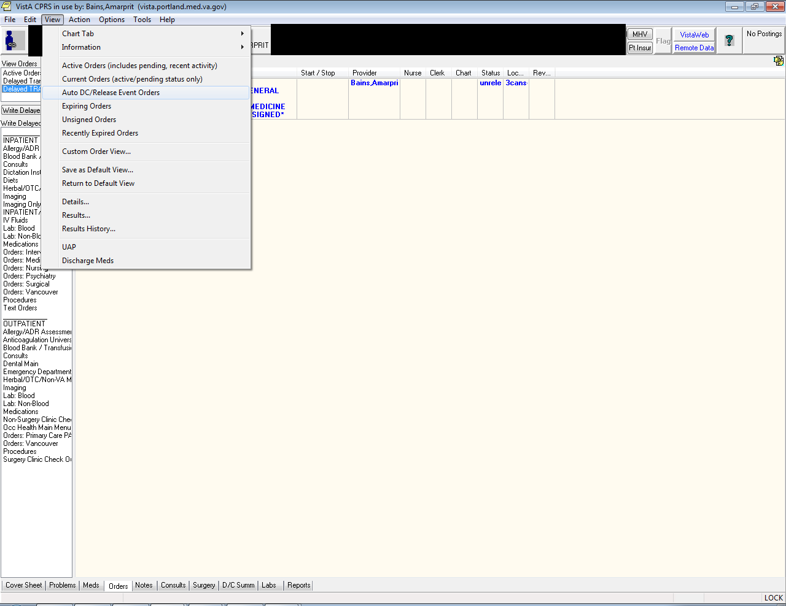
  - It will bring up this little window. This window shows every time the patient has been either admitted or transferred for the specified number of events.
    - The most recent event is at the top
    - In the example below I have chosen to show the last two events. As you can see it shows the patient was admitted to Metabolic Service (The Hospitalist Service) and then had a “Treating Specialty Change” (went to the OR).
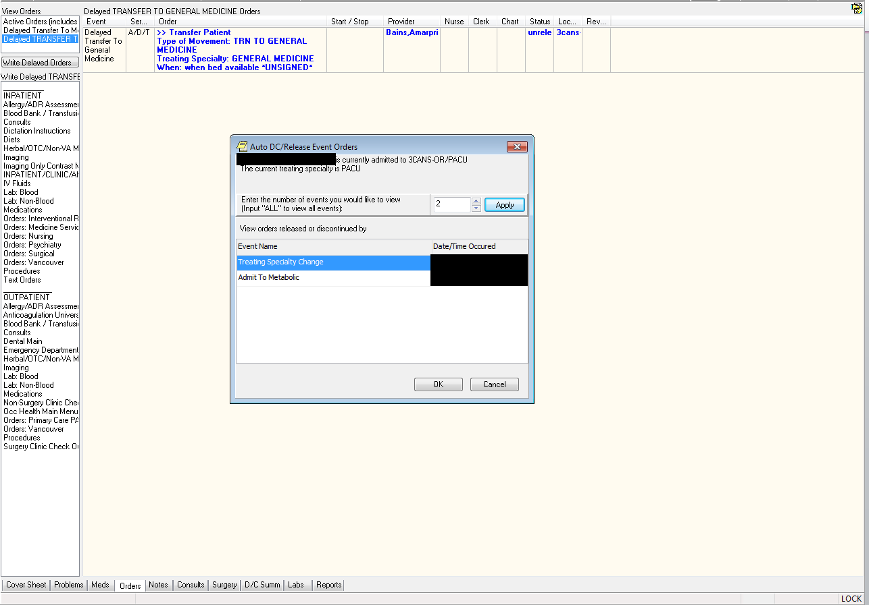
  - If I select “Treating Specialty Change’ and hit “OK” it will bring up all the orders that were active before the patient went to the OR.
  - Red Arrow: Notice they are all “discontinued” (as they should be).
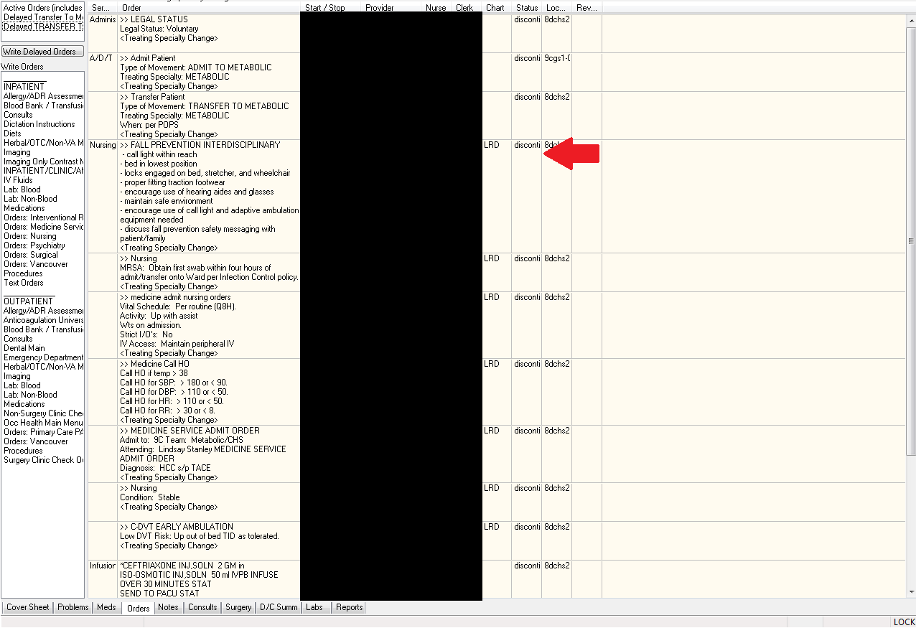
  - Select all the orders you want and, on the menu bar, choose ‘Action->Copy To New Order’
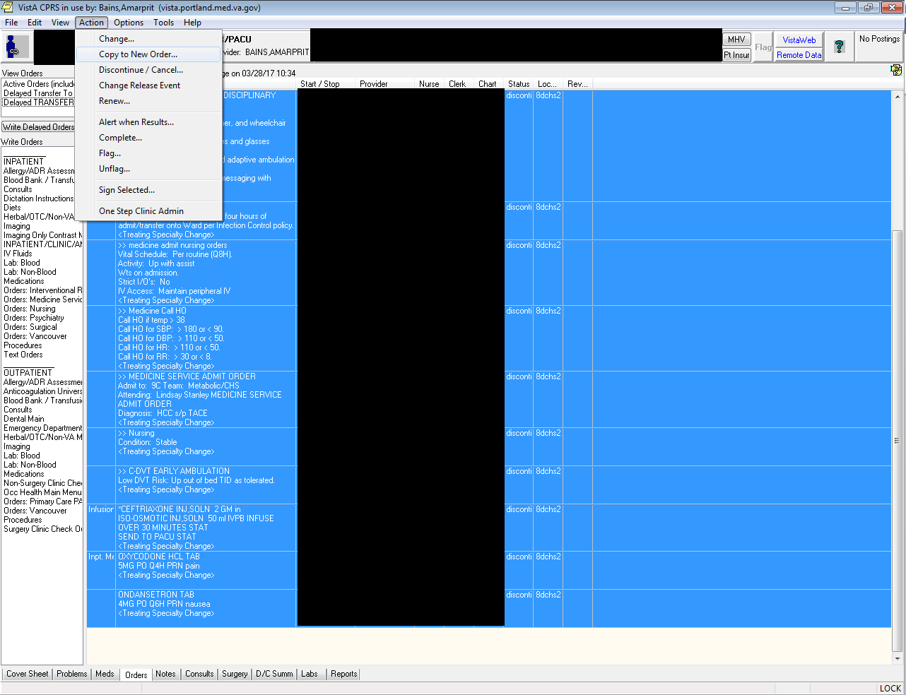

- Click on the “Delay release of copied orders” radio button and choose the appropriate service to Transfer back TO. This should be the same one you chose before
  - Tip: you can, if you want, start at the Auto Release/DC step and go from there. It will create a new Transfer Order for you
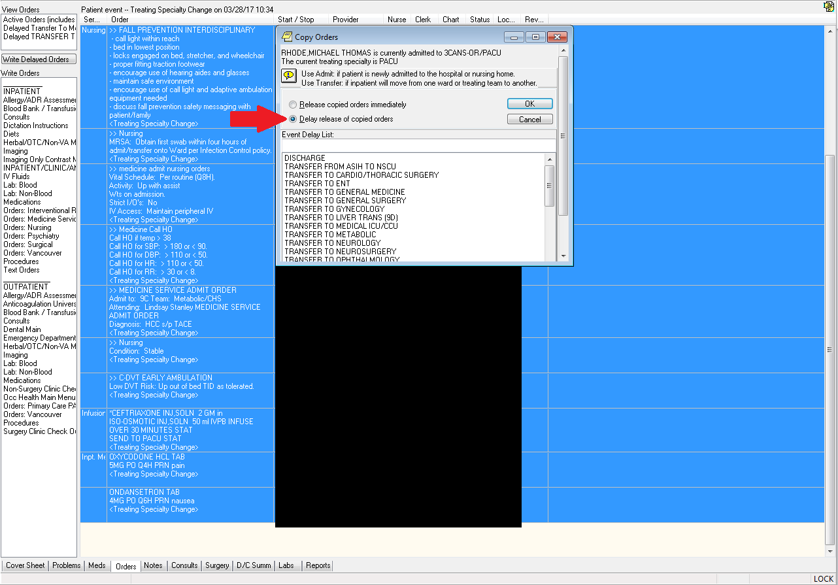
- Sign all the orders and you’re done
  - They’ll go active when the patient transfers back.

