How to view information from other VA facilities within CPRS
This applies to not just images but medications, vitals and labs. It essentially is taking the information you normally find in VistAWeb and putting it into CPRS
- Go to the Reports tab
  - Below is the default view in the reports tab. Notice that ‘Imaging (local)’ is highlighted
  - As the name would suggest, only reports from our local VA are being displayed
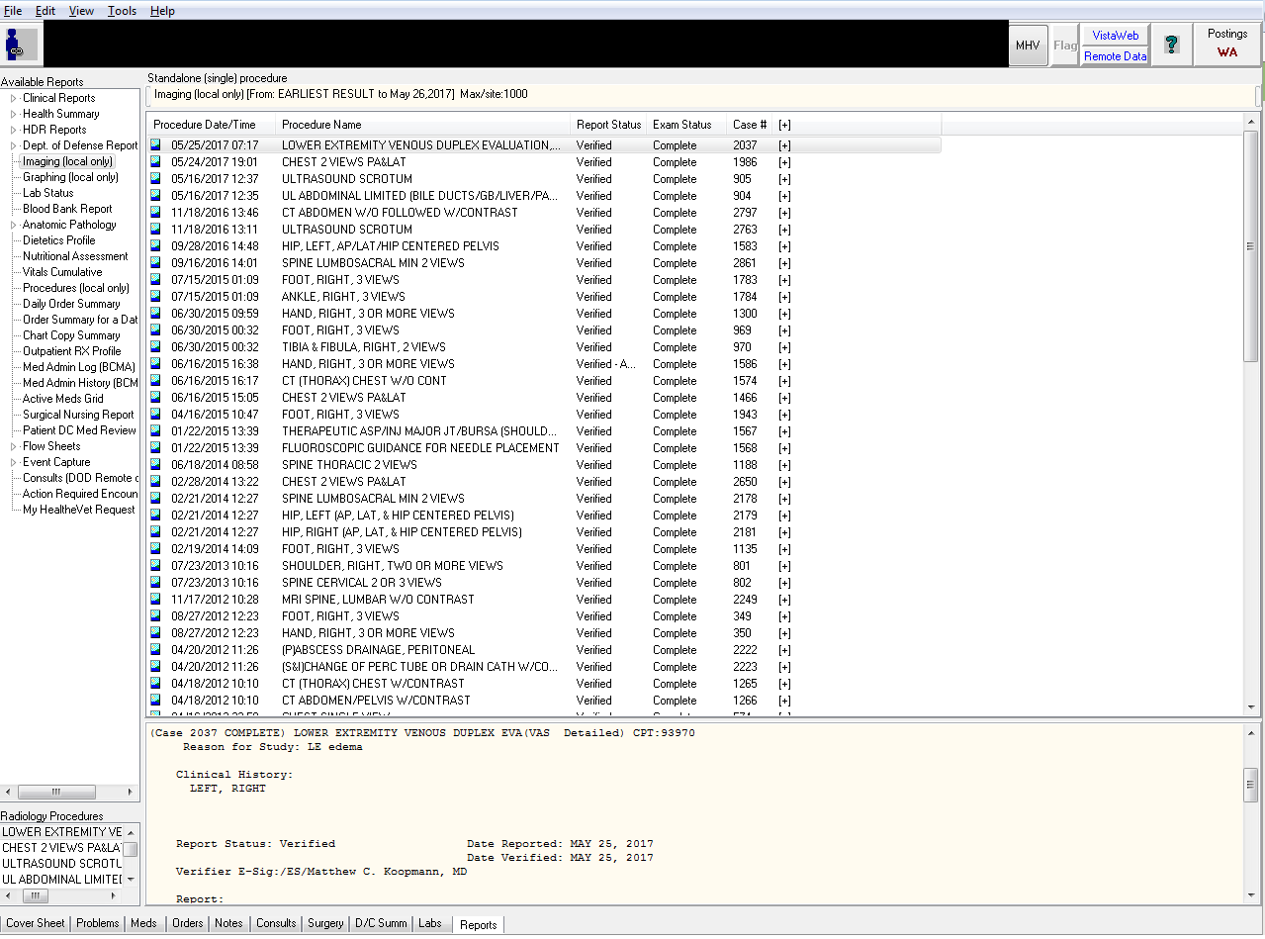
- The Remote Data Button
  - If the Remote Data button is blue it means there is data from other VA facilities available
  - Click on the remote data button to see what sites are available

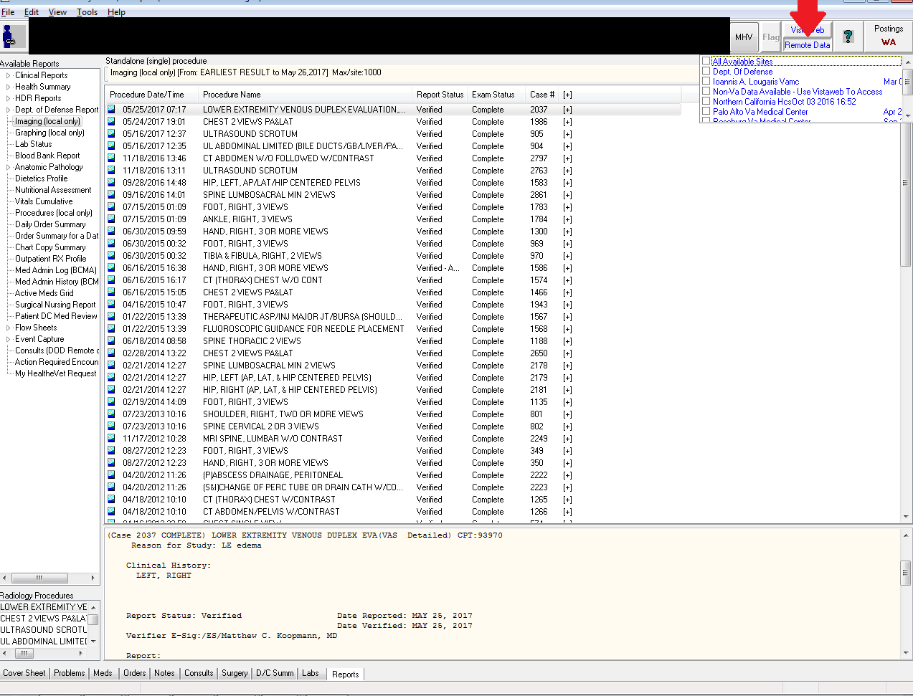

- Select which sites you want to import data from
  - The more sites you select the longer it will take to load though, generally, all sites will be fine
  - Red Arrow:
    - Select ‘All Available Sites’
  - CPRS will refresh
  - Click the Remote Data button again to make the little window with the sites go away
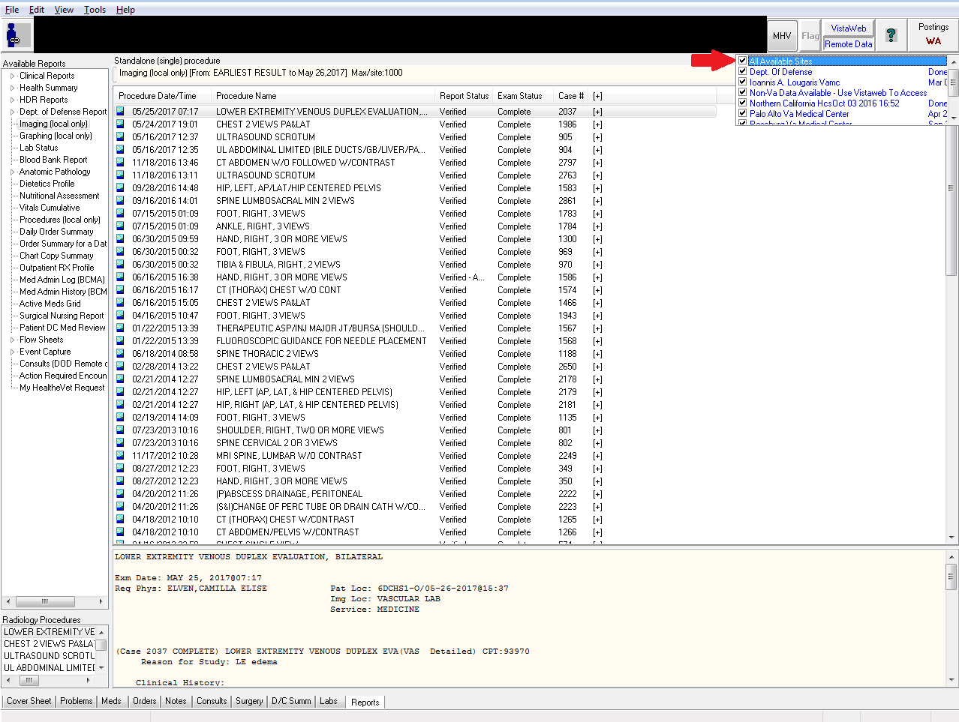

- Click on the little triangle next to ‘Clinical Reports’ to expand options
- Click on the little triangle next to Radiology to expand available options

- Select ‘Report’
  - Notice how other VA sites are listed (Northern California VA in this case)
  - Click on the individual study will bring up the radiology read below
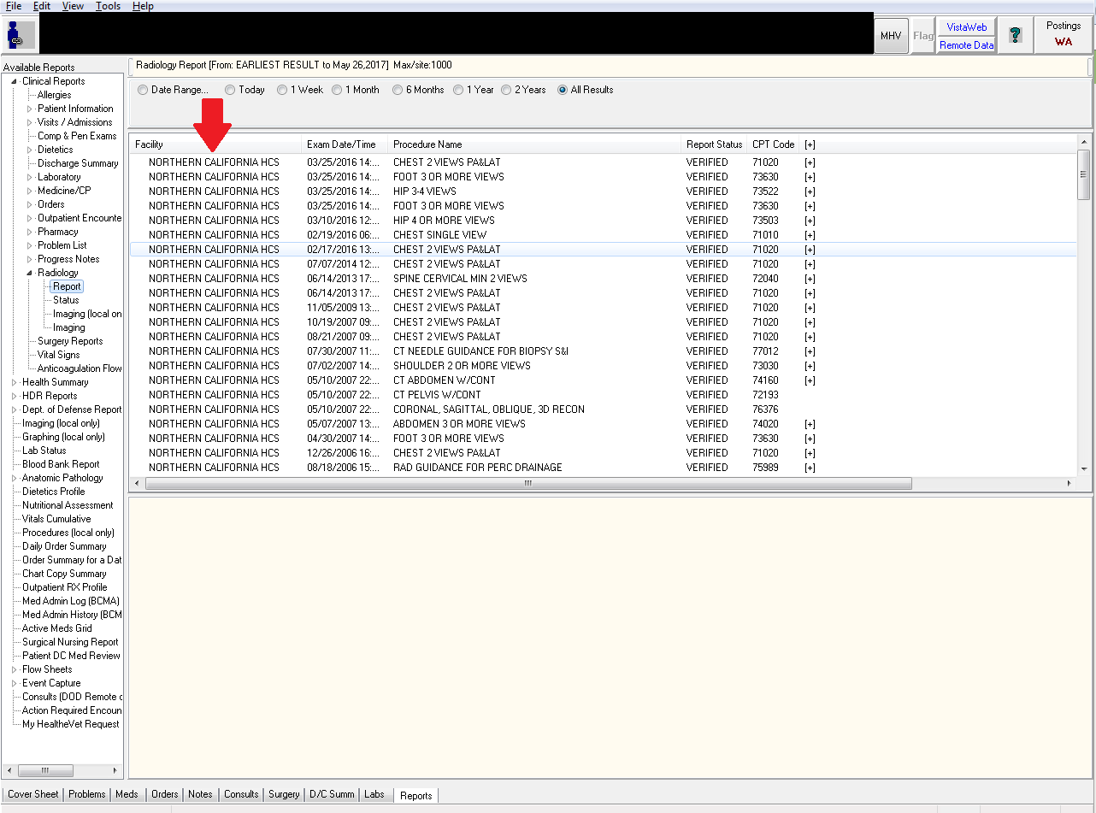

- To view Procedures, expand the ‘Medicine/CP’ section and choose ‘Brief Report’
  - Red Arrow:
    - In this example the Medicine/CP section has been expanded
  - Blue Arrow:
    - You can select which VA facility you want and it’ll show relevant EKGs, Echocardiograms and other procedures
    - Notice this patient has a 2005 TTE from the Sacramento VA with the report displayed just below it
  - Green Arrow:
    - Allows you to narrow the date range
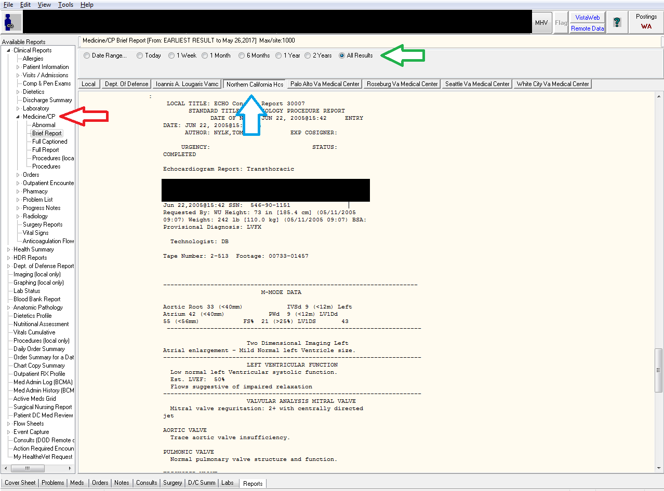

- Viewing remote medications
  - Red Arrow:
    - Still within the ‘Clinical Reports’ section, expand ‘Pharmacy’ and choose ‘All Medications’
  - Blue Arrow:
    - Notice the meds have all been imported from the remote data sites
  - Green Arrow:
    - The easiest way to go through these medications is probably to sort via Start Time but you can choose which method of sorting works best for you
  - As with local medications, clicking on the med will bring up details about it in the window below
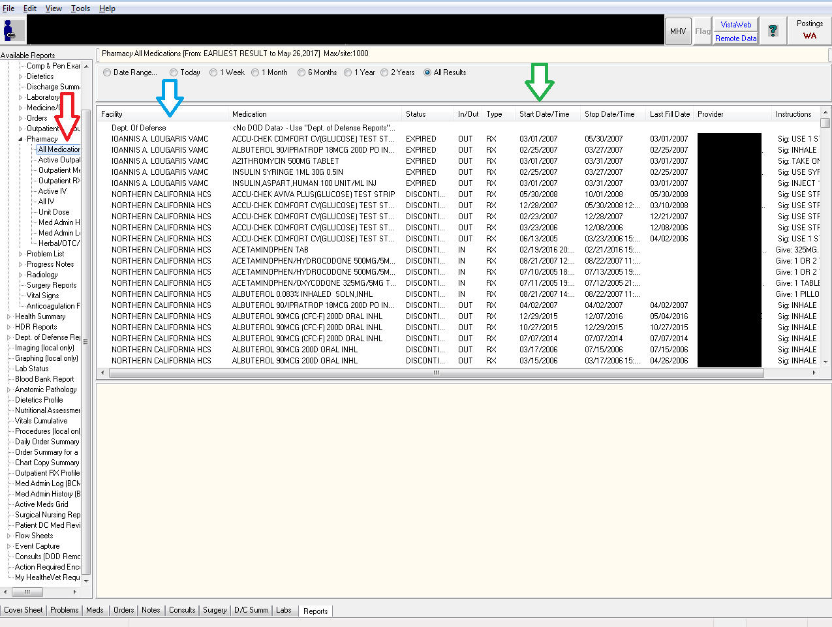
- This same method can be done for everything else in the ‘Clinical Reports’ section including labs, vitals and even progress notes
  - Choosing progress notes may lead to long load times so be careful when using it (though typically it should be fine)

