WEEK 4 –PATIENT SPECIFIC HGA1C GOALS AND SETTING SMART GOALS
How do you determine your HGA1C goal for each patient?

Per ADA GLYCEMIC GOALS IN ADULTS
- Lowering A1C to below or around 7% has been shown to reduce microvascular complications of diabetes and, if implemented soon after the diagnosis of diabetes, is associated with long-term reduction in macrovascular disease. Therefore, a reasonable A1C goal for many nonpregnant adults is ,7%. B
- Providers might reasonably suggest more stringent A1C goals (such as6.5%) for selected individual patients, if this can be achieved without significant hypoglycemia or other adverse effects of treatment. Appropriate patients might include those with short duration of diabetes, long life expectancy, and no significant CVD. C
- Less stringent A1C goals (such as 8%) may be appropriate for patients with a history of severe hypoglycemia, limited life expectancy, advanced microvascular or macrovascular complications, and extensive comorbid conditions and in those with long-standing diabetes in whom the general goal is difficult to attain despite diabetes self management education (DSME), appropriate glucose monitoring, and effective doses of multiple glucose lowering agents including insulin. B

Per VA DoD Guidelines:
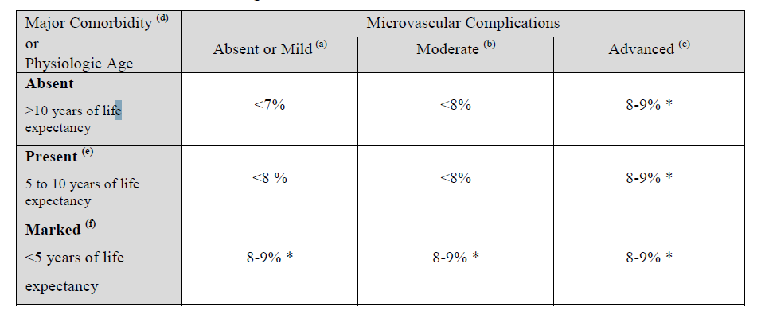

Understanding Goal Setting & Action Planning

What is Self-management?
- patients setting and achieving THEIR goals (not OUR goals)
- the daily actions taken (or not taken) by patients and caretakers that impact health

Making a specific Action Plan: SMART GOALS-one way to set goals with patients
The plan should contain all of the following steps:

- SPECIFIC:
  - Exactly what are you going to do? How will you eat less, how far will you walk, what meditative technique will you practice?
- MEASURABLE
  - How much will you do? Will you walk 2 blocks walk for 20 minutes, not eat between meals for 2 days, practice yoga for 10 minutes?
  - When will you do this? Will you do this before lunch, in the shower, when I arrive home from work?
  - How often will you do the activity? It’s important to begin with a frequency that is reasonable, to start slowly and build successes. If they do more, so much the better but the goal is to do the activity often enough to be successful, and yet not feel pressured on a daily basis.
- ACHIEVABLE AND REALISTIC
  - Anticipate barriers. Help the patient imagine what might get in the way of their plan.
  - Potential solutions for barriers Ask the patient for ideas that might help them overcome the barriers
- TIMELY
  - Follow-up plan When, where and how you will check in with the patient about their experience with the plan

- **Importance rating On a scale of 1-10, with 1 being not important to make a change to 10 being most important to make a change, have the patient rate the level of importance to them.

- **Confidence rating On a scale of 1-10, with 1 being no confidence that the plan can be completed to 10 being absolutely certain that they can complete the plan, have the patient rate their confidence level.

Start when the patient has a confidence and importance level of 7 or greater (this is the belief that they can, and will, complete the entire contract)
Goals versus behavior-specific changes
Keep in mind the difference between a healthy change, a goal that is set to reach that change and the behavior required to attain that goal. For example:
- Healthy Change: Lose weight
Goal: lose 4 pounds in the next month
Behavior: eating carrots for a snack, not chocolate
- Healthy Change: Exercise more
Goal: exercise for 20 minutes twice a week
Behavior: walk to work
- Healthy Change: reduce stress levels
Goal: spend 15 minutes a day relaxing
Behavior: listen to meditation tape

